**Supplementary materials**

**Jokes from Reader’s Digest**

1. I have an inferiority complex, but it’s not a very good one.
2. I told my doctor that I broke my arm in two places. He told me to stop going to those places.
3. Q: What vegetable is cool, but not *that* cool?

A: Rad-ish.

1. I was wondering why the baseball kept getting bigger and bigger, and then it hit me.
2. Q: Why did the employee get fired from the calendar factory?

A: She took a day off.

1. Worrying works! Case in point: 90% of the things I worry about never happen.
2. My teachers told me I’d never amount to much because I procrastinate. I told them, “Just you wait!”
3. Q: Why do seagulls fly over the sea?

A: If they flew over the bay, they would be bagels.

1. I ordered a chicken and an egg from Amazon. I’ll let you know which comes first.
2. Q: What do you call a magician who lost his magic?

A: Ian.

1. I broke my finger last week. On the other hand, I am OK.
2. I went to the doctor with a suspicious-looking mole. He told me they all look that way and I should have left it in the garden.
3. Two men are on opposite sides of the river. The first man shouts, “How do I get to the other side of the river?” The other man yells, “You *are* on the other side of the river!”
4. Q: Why would a pig dressed in black never get bullied?

A: Because Batman has sworn to protect Goth-ham.

1. Every morning, I announce that I’m going running, but then I don’t. It’s a running joke.
2. Q: Why is a swordfish’s nose 11 inches long?

A: Because if it were 12 inches, it would be a foot.

1. Q: What state is known for its small drinks?

A: Minnesota.

1. Q: What do you call a line of men waiting to get haircuts?

A: A barberqueue.

1. I was going to tell a time-traveling joke, but you didn’t like it.
2. I can’t take my dog to the pond anymore because the ducks keep attacking him. That’s what I get for buying a pure bread dog.
3. My wife and I laugh about how competitive we are. But I laugh more.
4. Q: Why did the hipster burn his mouth?

A: He drank the coffee before it was cool.

1. I know they say money talks, but all mine says is “goodbye.”
2. Q: Why should you never fall in love with a tennis player?

A: Because to them, love means nothing!

1. I gave up my seat to an elderly person on the bus. And that’s how I lost my job as a bus driver.
2. How do you find Will Smith in the snow? Look for the fresh prints.
3. Do I know any jokes about sodium? Na.
4. 70% of the earth is water, and virtually none of it is carbonated. So, the earth is, in fact, flat.
5. Q: If you have six oranges in one hand and eight bananas in another, what do you have? A: Big hands.
6. My wife told me to stop impersonating a flamingo. I had to put my foot down.
7. Q: What did zero say to eight?

A: Nice belt.

1. What’s the difference between ignorance and apathy? I don’t know, and I don’t care.
2. The past, the present and the future walked into a bar. It was tense.
3. I just found out the company that produces yardsticks won’t be making them any longer.
4. Geology rocks, but geography is where it’s at.
5. What’s the difference between black-eyed peas and chickpeas? Black Eyed Peas can sing us a song. Chickpeas can hummus one.
6. Q: What did the duck say when she bought lipstick?

A: Put it on my bill.

1. Did you hear that Larry got a new job working for Old MacDonald? He’s the new CIEIO.
2. Apparently, you can’t use the words “beef stew” as a password. It’s just not stroganoff.
3. What’s the best thing about Switzerland? I don’t know, but the flag is a big plus.
4. I invented a new word! Plagiarism!
5. Did you hear about the mathematician who’s afraid of negative numbers? He’ll stop at nothing to avoid them.
6. Q: Why do we tell actors to “break a leg?”

A: Because every play has a cast.

1. Helvetica and Times New Roman walk into a bar. “Get out of here!” shouts the bartender. “We don’t serve your type.”
2. Yesterday I saw a guy spill all his Scrabble letters on the road. I asked him, “What’s the word on the street?”
3. Knock! Knock!

Who’s there?

Control Freak.

Con…

OK, now you say, “Control Freak who?”

1. Hear about the new restaurant called Karma? There’s no menu: You get what you deserve.
2. A woman in labor suddenly shouted, “Shouldn’t! Wouldn’t! Couldn’t! Didn’t! Can’t!” “Don’t worry,” said the doc. “Those are just contractions.”
3. A bear walks into a bar and says, “Give me a whiskey and … cola.” “Why the big pause?” asks the bartender. The bear shrugged. “I’m not sure; I was born with them.”
4. Did you hear about the actor who fell through the floorboards? He was just going through a stage.
5. Did you hear about the claustrophobic astronaut? He just needed a little space.
6. Q: Why don’t scientists trust atoms?

A: Because they make up everything.

1. Q: Where are average things manufactured?

A: The satisfactory.

1. Q: How do you drown a hipster?

A: Throw him in the mainstream.

1. Q: What sits at the bottom of the sea and twitches?

A: A nervous wreck.

1. Q: What does a nosy pepper do?

A: Gets jalapeño business!

1. Q: Why can’t you explain puns to kleptomaniacs?

A: They always take things literally.

1. Q: How do you keep a bagel from getting away?

A: Put lox on it.

1. A man tells his doctor, “Doc, help me. I’m addicted to Twitter!” The doctor replies, “Sorry, I don’t follow you …”
2. Q: What kind of exercise do lazy people do?

A: Diddly-squats.

1. Q: Why don’t Calculus majors throw house parties?

A: Because you should never drink and derive.

1. Q: What do you call a parade of rabbits hopping backwards?

A: A receding hare-line.

1. Q: What does Charles Dickens keep in his spice rack?

A: The best of thymes, the worst of thymes.

1. Q: What’s the different between a cat and a comma?

A: A cat has claws at the end of paws.

1. Q: What did the Tin Man say when he got run over by a steamroller?

A: “Curses! Foil again!”

1. Q: What did the bald man exclaim when he received a comb for a present?

A: Thanks— I’ll never part with it!

1. Q: What did the left eye say to the right eye?

A: Between you and me, something smells.

1. Q: What do you call a fake noodle?

A: An impasta.

1. Q: How do you make a tissue dance?

A: Put a little boogie in it.

1. Q: What do you call a pony with a cough?

A: A little horse.

1. Q: What did one hat say to the other?

A: You wait here. I’ll go on a head.

1. Q: What did the shark say when he ate the clownfish?

A: This tastes a little funny.

1. Q: Why can’t you hear a pterodactyl go to the bathroom?

A: Because the “P” is silent.

1. Q: What did the pirate say when he turned 80?

A: Aye matey.

1. Q: Why did the frog take the bus to work today?

A: His car got toad away.

1. Q: What did the buffalo say when his son left for college?

A: Bison.

1. Q: Why did the yogurt go to the art exhibition?

A: Because it was cultured.

1. Q. What do you call an apology written in dots and dashes?

A: Re-Morse code.

1. I told my wife she was drawing her eyebrows too high. She looked at me surprised.
2. Did you hear about the two people who stole a calendar? They each got six months.
3. Q: What’s Forest Gump’s password?

A: 1Forest1.

1. Q: How do poets say hello?

A: Hey, haven’t we metaphor?

1. Q: Why did the Oreo go to the dentist?

A: Because he lost his filling.

1. Q: What do you get from a pampered cow?

A: Spoiled milk.

1. Q: Why is it annoying to eat next to basketball players?

A: They dribble all the time.

1. Q: Why did the M&M go to school?

A: It wanted to be a Smartie.

1. Q: Why do bees have sticky hair?

A: Because they use honeycombs.

1. I got my daughter a fridge for her birthday. I can’t wait to see her face light up when she opens it.
2. Q: Why aren’t koalas actual bears?

A: They don’t meet the koalafications.

1. Rest in peace to boiling water. You will be mist.
2. Q: What do you call a rooster staring at a pile of lettuce?

A: A chicken sees a salad.

1. Q: Why did the nurse need a red pen at work?

A: In case she needed to draw blood.

1. Q: How do you throw a space party?

A: You planet.

1. The numbers 19 and 20 got into a fight. 21.
2. Q: Why did it get so hot in the baseball stadium after the game?

A: All of the fans left.

1. Q: Why did the math textbook visit the guidance counselor?

A: It needed help figuring out its problems.

1. Want to hear a construction joke? Oh never mind, I’m still working on that one.
2. Talk is cheap? Have you ever talked to a lawyer?
3. Q: Why did the gym close down?

A: It just didn’t work out!

1. Two artists had an art contest. It ended in a draw!
2. I tried to sue the airport for misplacing my luggage. I lost my case.
3. I have a fear of speed bumps. But I am slowly getting over it.
4. Q: What did one traffic light say to the other?

A: Stop looking! I’m changing!

1. Q: What type of sandals do frogs wear?

A: Open-toad!

1. Q: Why was six afraid of seven?

A: Because seven ate nine.

1. Q: What starts with E, ends with E, and has only 1 letter in it?

A: Envelope.

1. Q: Why doesn’t the sun go to college?

A: Because it has a million degrees!

1. Q: Why are skeletons so calm?

A: Because nothing gets under their skin.

1. Q: Why is England the wettest country?

A: Because so many kings and queens have been reigning there.

1. Did you hear about the kidnapping at school? It’s okay. He woke up.
2. Q: Can February march?

A: No, but April may.

1. Q: Why are ghosts such bad liars?

A: Because they are easy to see through.

1. Q: How do trees get online?

A: They just log on!

1. Q: What do you call a bear with no teeth?

A: A gummy bear.

1. Q: Why couldn’t the leopard play hide and seek?

A: Because he was always spotted.

1. A pair of cows were talking in the field.

One says, “Have you heard about the mad cow disease that’s going around?”

“Yeah,” the other cow says. “Makes me glad I’m a penguin.”

1. Q: Why don’t pirates take a shower before they walk the plank?

A: They just wash up on shore.

1. Two hunters are out in the woods when one of them collapses. He’s not breathing and his eyes are glazed. The other guy whips out his cell phone and calls 911.

“I think my friend is dead!” he yells. “What can I do?”

The operator says, “Calm down. First, let’s make sure he’s dead.”

There’s a silence, then a shot. Back on the phone, the guy says, “OK, now what?”

1. A highway patrolman pulled alongside a speeding car on the highway. Looking at the car, he was astounded to see that the elderly woman behind the wheel was knitting. The trooper cranked down his window and yelled to the driver, “Pull over!”

“No!” the woman yelled back, “Cardigan!”

1. I quit my job working for Nike. I just couldn’t do it anymore.
2. Sad after the funeral of a friend, my wife and I ducked into a Chinese restaurant for a pick-me-up. The feel-good session ended when I read the fortune cookie: “You will soon be reunited with a good friend.”
3. I tried to organize a hide-and-seek tournament, but it was a complete failure. Good players are hard to find.
4. A vegan said to me, “People who sell meat are gross!”

I said, “People who sell veggies are grocer.”

1. A mom texts, “Hi! Son, what do IDK, LY and TTYL mean?”

He texts back, “I don’t know, love you and talk to you later.”

The mom replies, “It’s OK, don’t worry about it. I’ll ask your sister. Love you too.”

1. Why do they lock gas station bathrooms? Are they afraid someone will clean them?
2. Interesting fact: a shark will only attack you if you’re wet.
3. A guy spots a sign outside a house that reads “Talking Dog for Sale.” Intrigued, he walks in.

“So what have you done with your life?” he asks the dog.

“I’ve led a very full life,” says the dog. “I lived in the Alps rescuing avalanche victims. Then I served my country in Iraq. And now I spend my days reading to the residents of a retirement home.”

The guy is flabbergasted. He asks the dog’s owner, “Why on Earth would you want to get rid of an incredible dog like that?”

The owner says, “Because he’s a liar! He never did any of that!”

1. A poodle and a collie are walking together when the poodle suddenly unloads on his friend. “My life is a mess,” he says. “My owner is mean, my girlfriend ran away with a schnauzer, and I’m as jittery as a cat.”

“Why don’t you go see a psychiatrist?” suggests the collie.

“I can’t,” says the poodle. “I’m not allowed on the couch.”

1. The easiest time to add insult to injury is when you’re signing somebody’s cast.
2. I decided to sell my vacuum cleaner. All it was doing was gathering dust.
3. Is there rehab for gossiping?I don’t need it, but I’ll tell you who does…
4. A skeleton walks into a bar. The bartender says, “What’ll you have?”

The skeleton says, “Gimme a beer and a mop.”

1. I like an escalator because an escalator can never break. It can only become stairs.
2. The village blacksmith finally found an apprentice willing to work hard for long hours. The blacksmith instructed the boy, “When I take the shoe out of the fire, I’ll lay it on the anvil; and when I nod my head, you hit it with this hammer.”

The apprentice did just as he was told. Now he’s the village blacksmith.

1. Doctor: “I’m sorry but you suffer from a terminal illness and have only 10 to live.” Patient: “What do you mean, 10? Ten what? Months? Weeks?!”

Doctor: “Nine.”

1. Two men were driving home one night when one asked the other to check if the car’s indicators are working. He promptly sticks his head out the window and says: “Yes, no, yes, no, yes, no, yes, no.”
2. A man is on trial for armed robbery. The jury comes back with the verdict. The foreman stands, clear his throat and announces, “Not guilty.”  
   The defendant leaps to his feet. “Awesome!” he shouts. “Does that mean I get to keep the money?”
3. The manager of a jewelry store nabs a shoplifter trying to steal a necklace.

“Listen,” the crook says, “you don’t want any trouble, and neither do I. What do you say I just buy the necklace and we forget this ever happened?” The manager agrees and writes up a sales slip. “You know,” says the crook, “this is more than I wanted to spend. Got anything less expensive?”

1. Snake 1: Are we poisonous? Snake 2: I don’t know. Why? Snake 1: I just bit my lip.
2. What did the green grape say to the purple grape? Breathe! Breathe!
3. “I think my goldfish has seizures,” a man tells the veterinarian.

“He seems fine now,” says the vet.

“Now, sure. But wait till I take him out of the bowl.”

1. Q: You’re riding a horse at full speed. You’re being chased by a lion and there’s a giraffe in the way in front of you. How will you escape this highly dangerous situation?

A: Get off the carousel.

1. A woman walked up to an elderly man rocking in a chair on his porch. “I couldn’t help noticing how happy you look,” she said. “What’s your secret for a long, happy life?”

“I smoke three packs of cigarettes a day,” he said. “I also drink a case of whisky a week, eat fatty foods and never exercise.”

“That’s amazing,” the woman said. “How old are you?”

“Thirty-six.”

1. The other day I was thinking, “I must be the most unobservant person in the world.” Then I thought, “Well, maybe other people are equally unobservant, and I just haven’t noticed before.”
2. A couple of cockroaches are munching on the contents of a garbage can in a deserted alley. “Have you popped into that new coffee shop across the street yet?” asks one. “The floors are so shiny you can see your antennae in them. The walls are so clean you can’t run up them. The air is so fresh it smells like flowers.”

“Stop!” cries the second cockroach. “Please, not while I’m eating.”

1. Q: How many college students does it take to screw in a light bulb?

A: One, but he waits until the last minute to cram it in.

1. A husband texts his wife on a frosty winter morning: “Window’s frozen!”

His wife texts back, “Pour lukewarm water over it.”

Five minutes later he replies: “Computer completely messed up now.”

1. One friend complains to another, “All my husband and I do any more is fight. I’ve been so upset, I’ve lost 20 pounds.”

“If it’s that bad, why don’t you just leave him?” asks the other friend.

“I’d like to lose another 15 pounds first.”

1. You know, people don’t usually compliment me on my driving, so I was very pleased this morning when I saw a note on my car that said, “Parking fine.” That was very nice of them!
2. Q: What did the gingerbread man put on his bed?

A: Cookie sheets.

1. Q: Where do loose tea leaves go to rest while they’re camping?

A: A steeping bag.

1. Did you hear about the identical twins who robbed a bank? After they were caught, they finished each other’s sentences.
2. Fortune tellers are so easy to buy clothes for—they’re all mediums.
3. A man is recovering from a minor surgery when a nurse comes in to check on him.  
   “How are you feeling?” she asks.  
   “I’m okay,” he says, “but I didn’t like the four-letter word the doctor used during surgery.”  
   “What did he say?” the nurse asks.  
   “Oops.”
4. Change is inevitable, except from a vending machine.
5. There is a lot of competition for parking at the local dental office, hence the sign: “Dental office parking only. Violators will be extracted.”
6. Green beans are the most zen of all the vegetables because they’ve found their inner peas.
7. I went to the butcher’s the other day and bet him $50 that he couldn’t reach the meat on the top shelf. “No,” he responded. “The steaks are too high.”
8. The trouble with jogging is that by the time you realize you’re not in shape for it, it’s too far to walk back.
9. My IQ test results came back. They were negative.
10. Q: What did one DNA say to the other DNA?

A: “Do these genes make me look fat?”

1. Q: What do you get when you cross a polar bear with a seal?

A: A polar bear.

1. Q: What’s the difference between an outlaw and an in-law?

A: Outlaws are wanted.

1. Before you marry a person, you should first make them use a computer with a slow

Internet connection to see who they really are.

1. Did you hear about the shepherd who drove his sheep through town? He was given a

ticket for making a ewe turn.

1. Among the things that are so simple even a child can operate them are parents.
2. Q: Why aren’t dogs good dancers?

A: Because they have two left feet.

1. Q: Why did Beethoven get rid of his chickens?

A: All they said was, “Bach, Bach, Bach …”

1. I spent a lot of time, money and effort childproofing my house … but the kids still get in.
2. Q: What do you call a mobster who’s buried in cement?

A: A hardened criminal.

1. Did you hear about the nurse who was chewed out by the doctor because she was

absent without gauze?

1. Did you hear about the crustacean accused of promoting his own shellfish interests?
2. Did you hear about the cat who ate a ball of yarn? She had mittens.
3. Q: Where does a winemaker get his gossip?

A: Through the grapevine.

1. Q: How many telemarketers does it take to change a light bulb?

A: Only one, but he has to do it while you are eating dinner.

1. Q: How much did Santa pay for his sleigh?

A: Nothing, it was on the house.

1. Q: What do you call Santa’s helpers?

A: Subordinate Clauses.

1. Q: What do you call a chicken who crosses the road, rolls in the mud and then crosses

back again?

A: A dirty double-crosser.

1. I used to believe that all things must pass—until I got stuck behind a school bus.
2. Q: Why don’t cats play poker in the jungle?

A: Too many cheetahs.

**Instructions**

*Note: notes to the reader are italicized, while actual text presented to participants is not.*

*Initial instructions:*

“This is a social game. You will be connected to two other people online. In this game, two players are randomly assigned to the role of sharing jokes, and one player is assigned to the role of receiving jokes. YOU HAVE BEEN ASSIGNED TO THE ROLE OF RECEIVING JOKES. A research assistant will oversee the game by choosing jokes in real time and sending them to the two other players. You will never interact with the research assistant, only the two players represented by pictures on the screen. When two buttons appear on the screen, you will have to make a choice. You can “join” the players, or you can “pass” on the opportunity to “interact” with them. If you join, other players could potentially share a joke with you. However, you will only get to see the joke if the other players decided to share it with you. If you pass, you will not see a joke, regardless of the other players' decision. However, you will find out whether the others had decided to share with you. You are free to choose between JOIN and PASS. Choosing JOIN versus PASS will not affect your earnings. You will earn $9.00 for participating, but those earnings could double based on performance during the game and survey.”

*During each practice trial, two silhouettes appeared on the screen in place of the other players’ images. Participants were told how to respond (e.g., “press JOIN” or “press PASS”) to ensure they experienced different outcomes across practice trials. Following completion of the practice trials, participants were asked to indicate the terms best describing their gender identity, as described previously. A blank screen with two silhouettes then appeared with text indicating “Finding other players…” and, after 3 s, “Connecting with other players…” Two images of faces appeared after an additional 3 s, as shown in Figures 1 and 2 of the main document (top-left panels). This was to give the impression that other individuals were joining the game remotely over the internet.*

**Note:** The following text appeared at the top of Pages 1-3. Silhouettes of players below are not the images presented during the task.

IMPORTANT INSTRUCTIONS

PLEASE READ TO ENSURE YOU RECEIVE PAYMENT

**\*\*\*There will be a short quiz at the end.\*\*\***

--

*PAGE 1:*

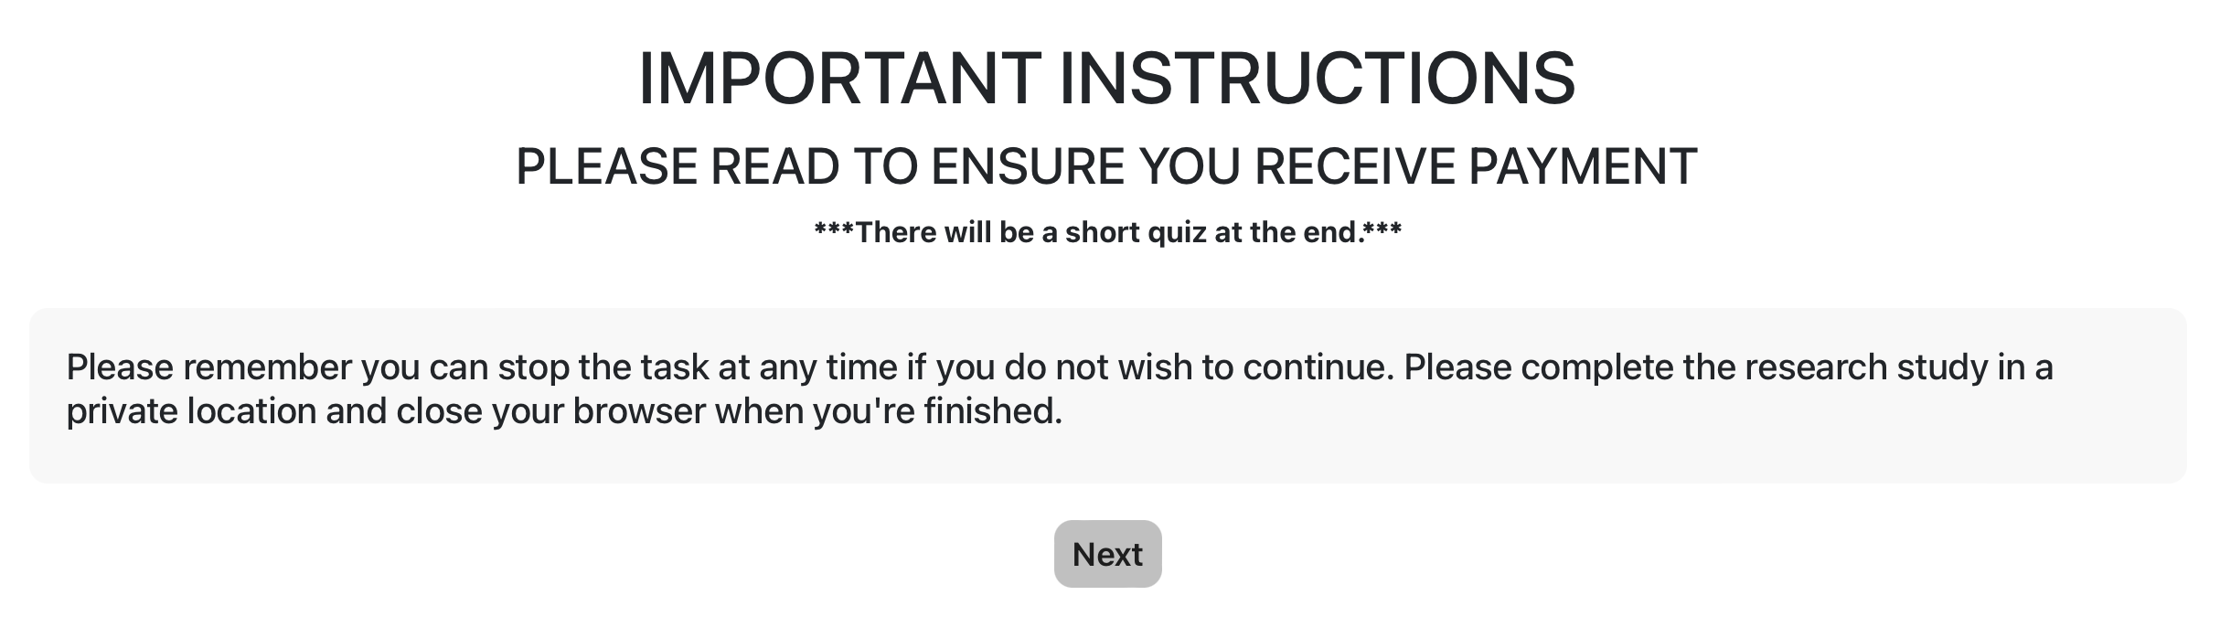

--

*PAGE 2:*

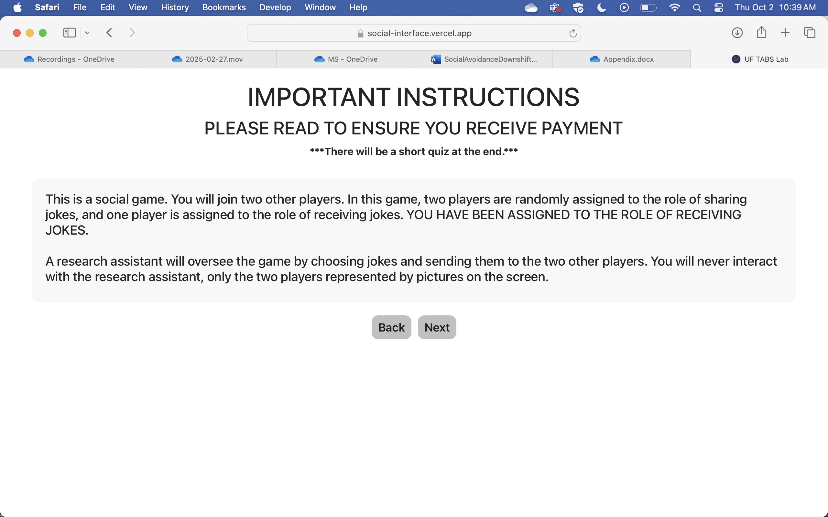

--

*PAGE 3:*

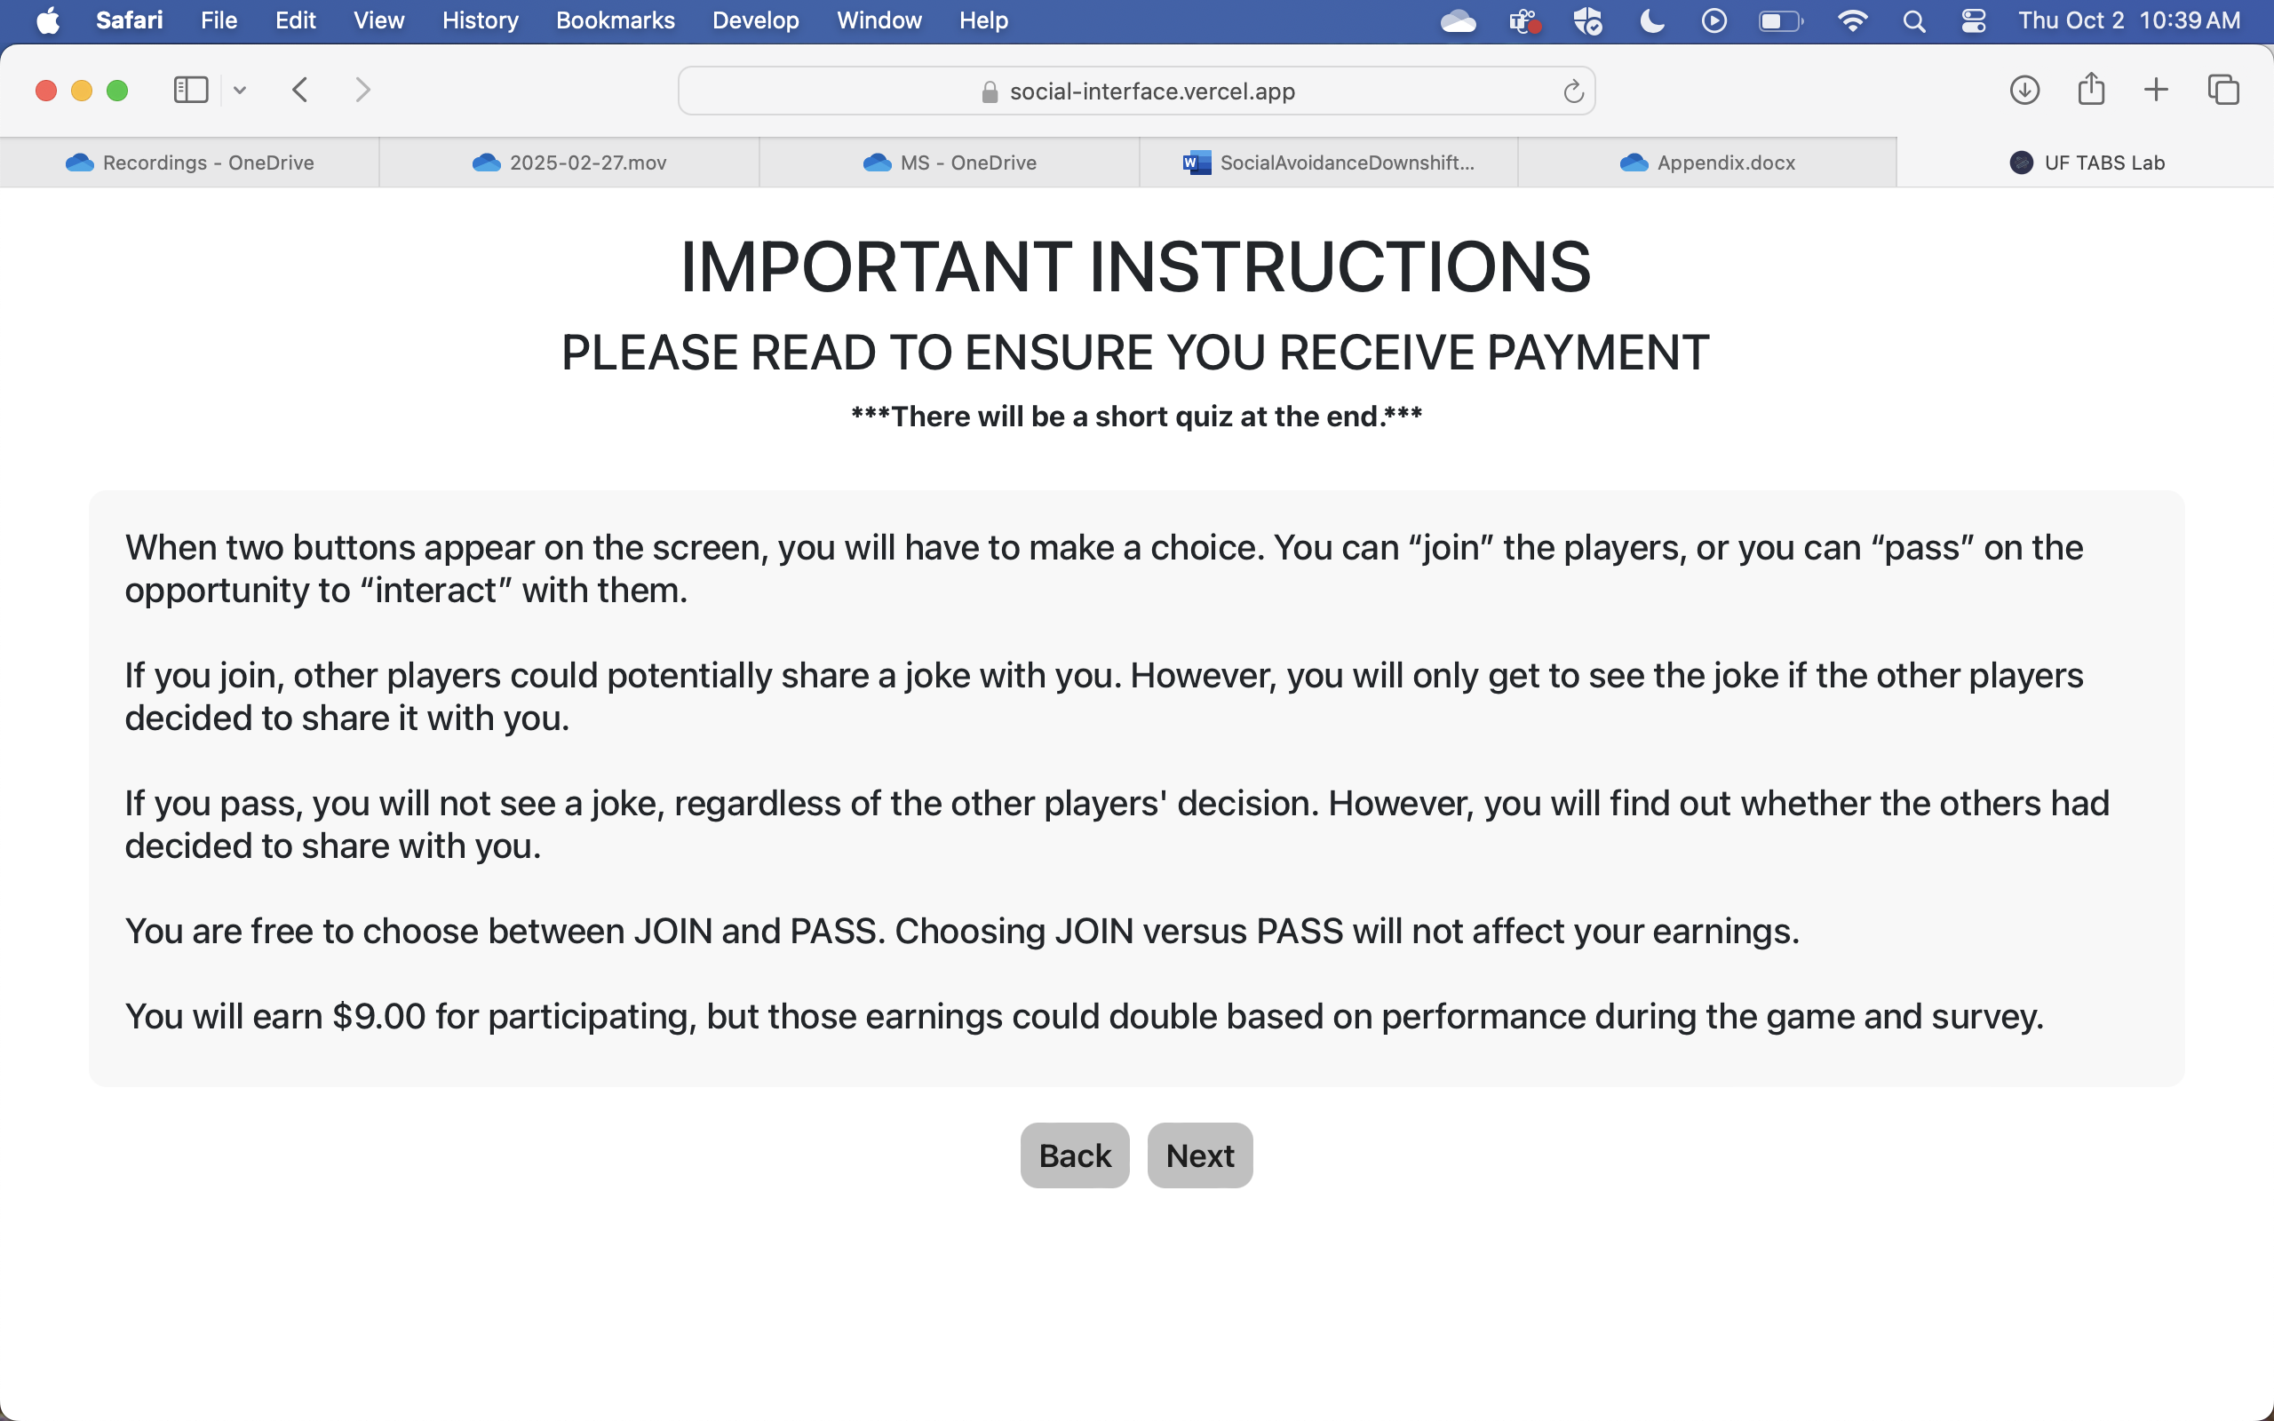

--

*PAGE 4:*

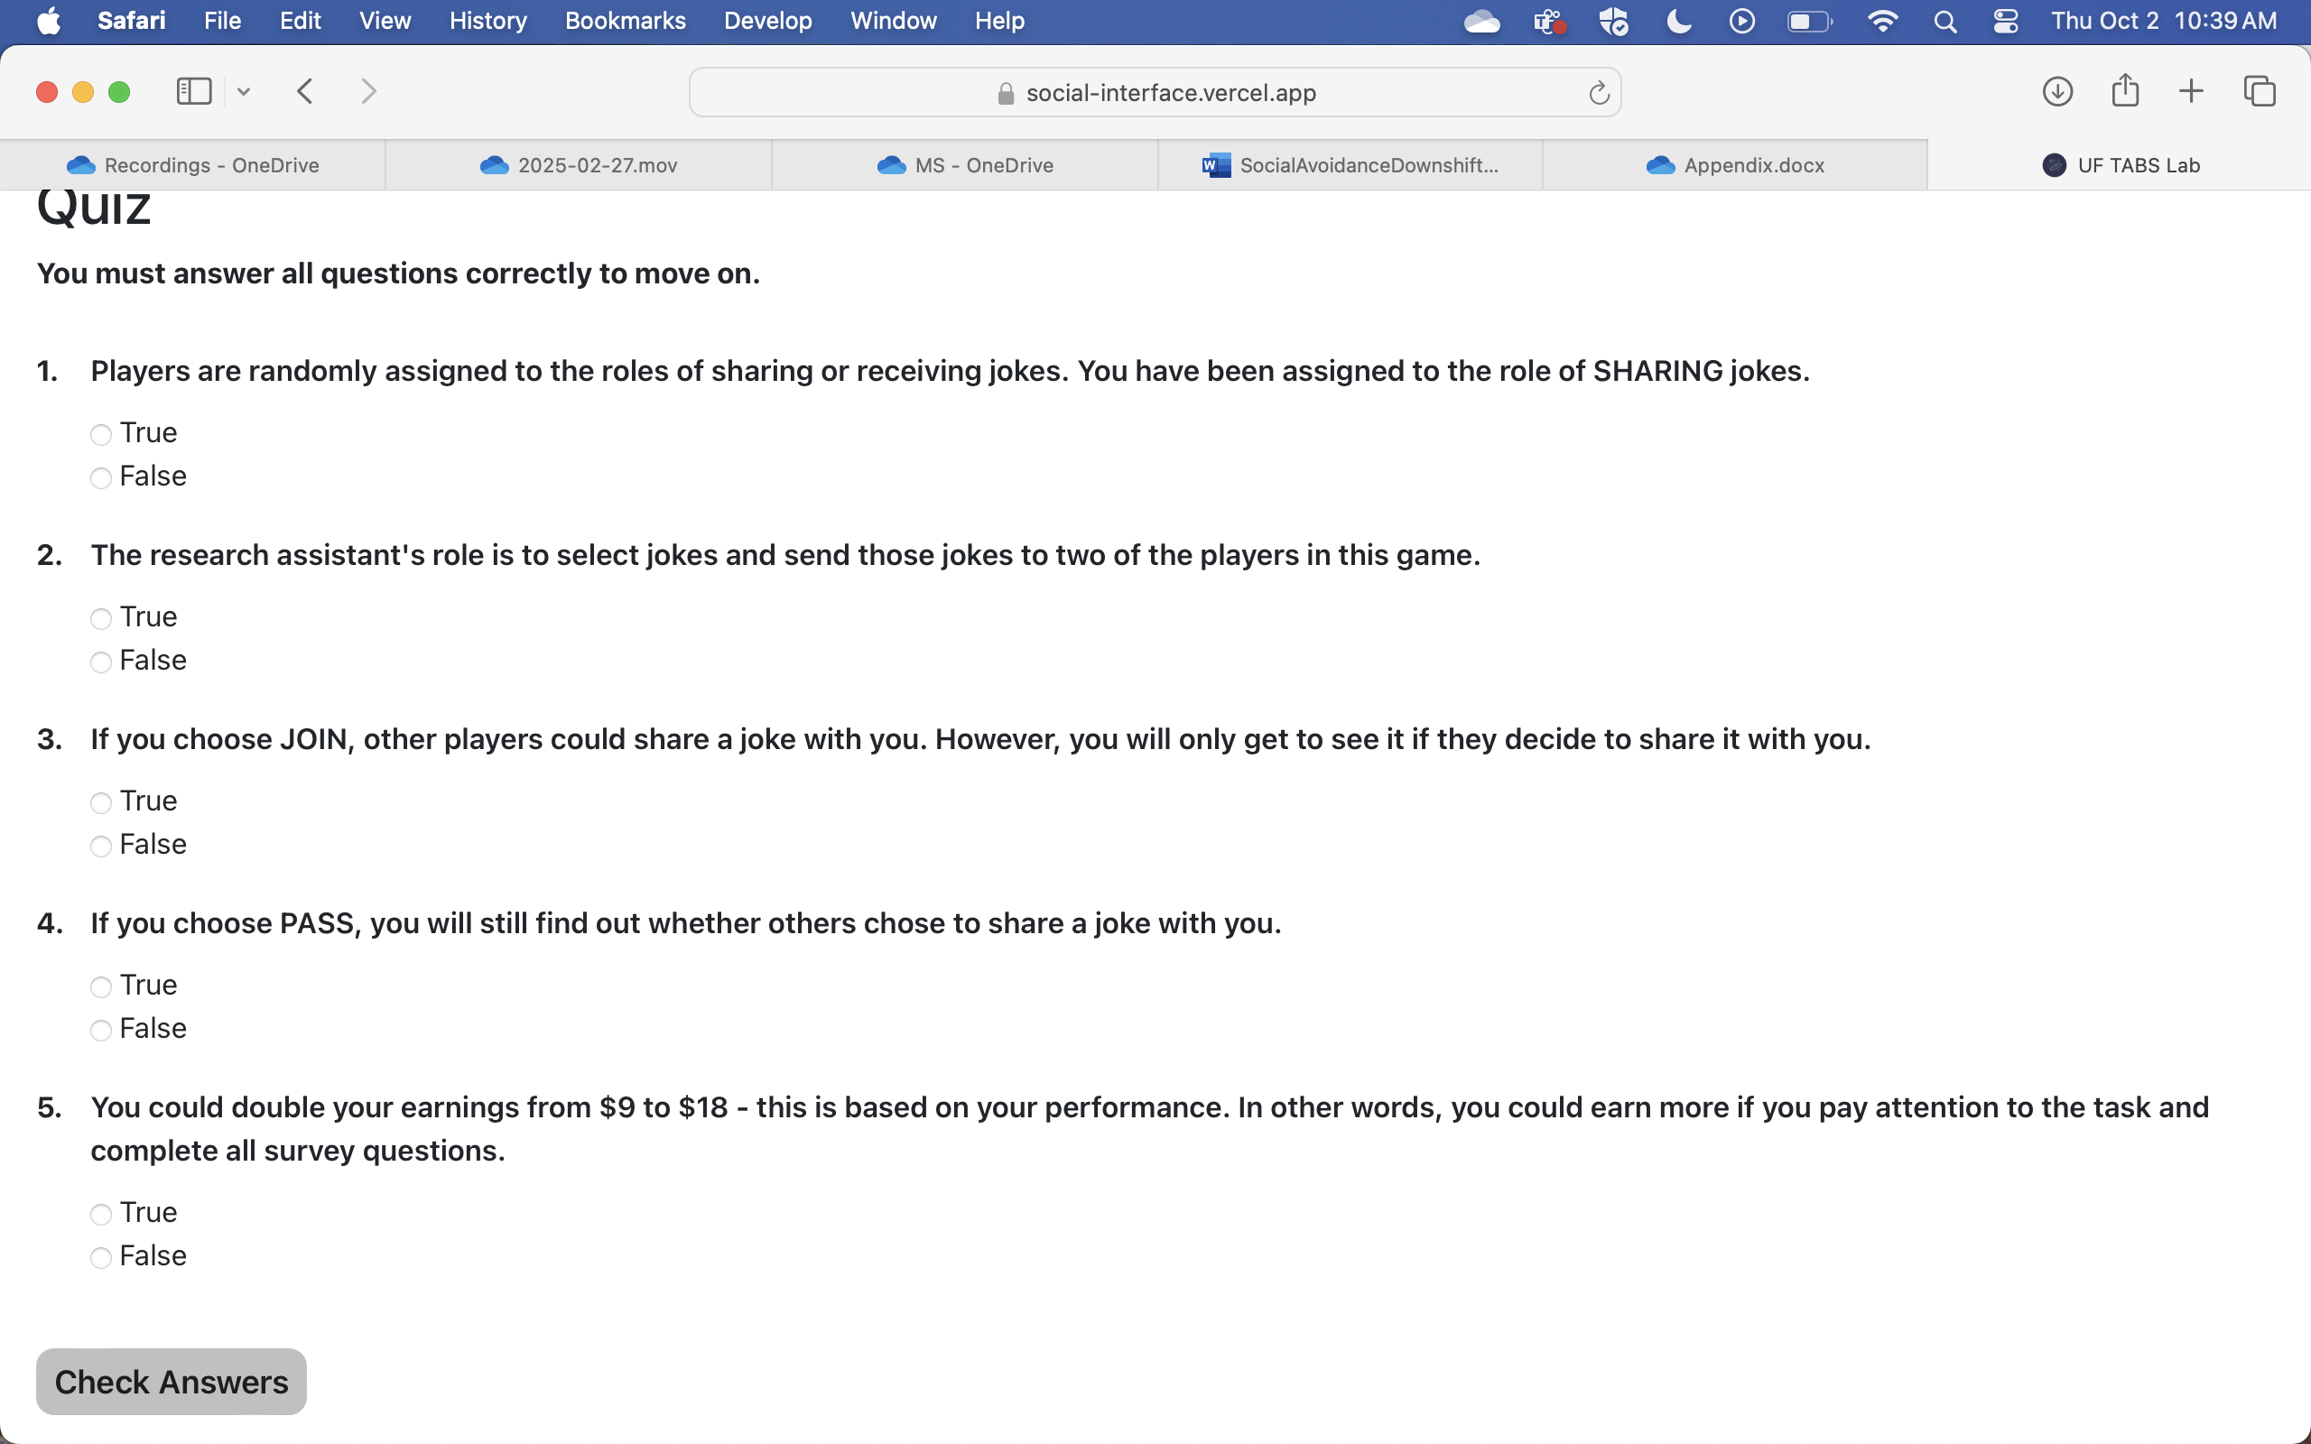

Quiz Answers:

1. False
2. True
3. True
4. True
5. True

**If all answers were correct:**

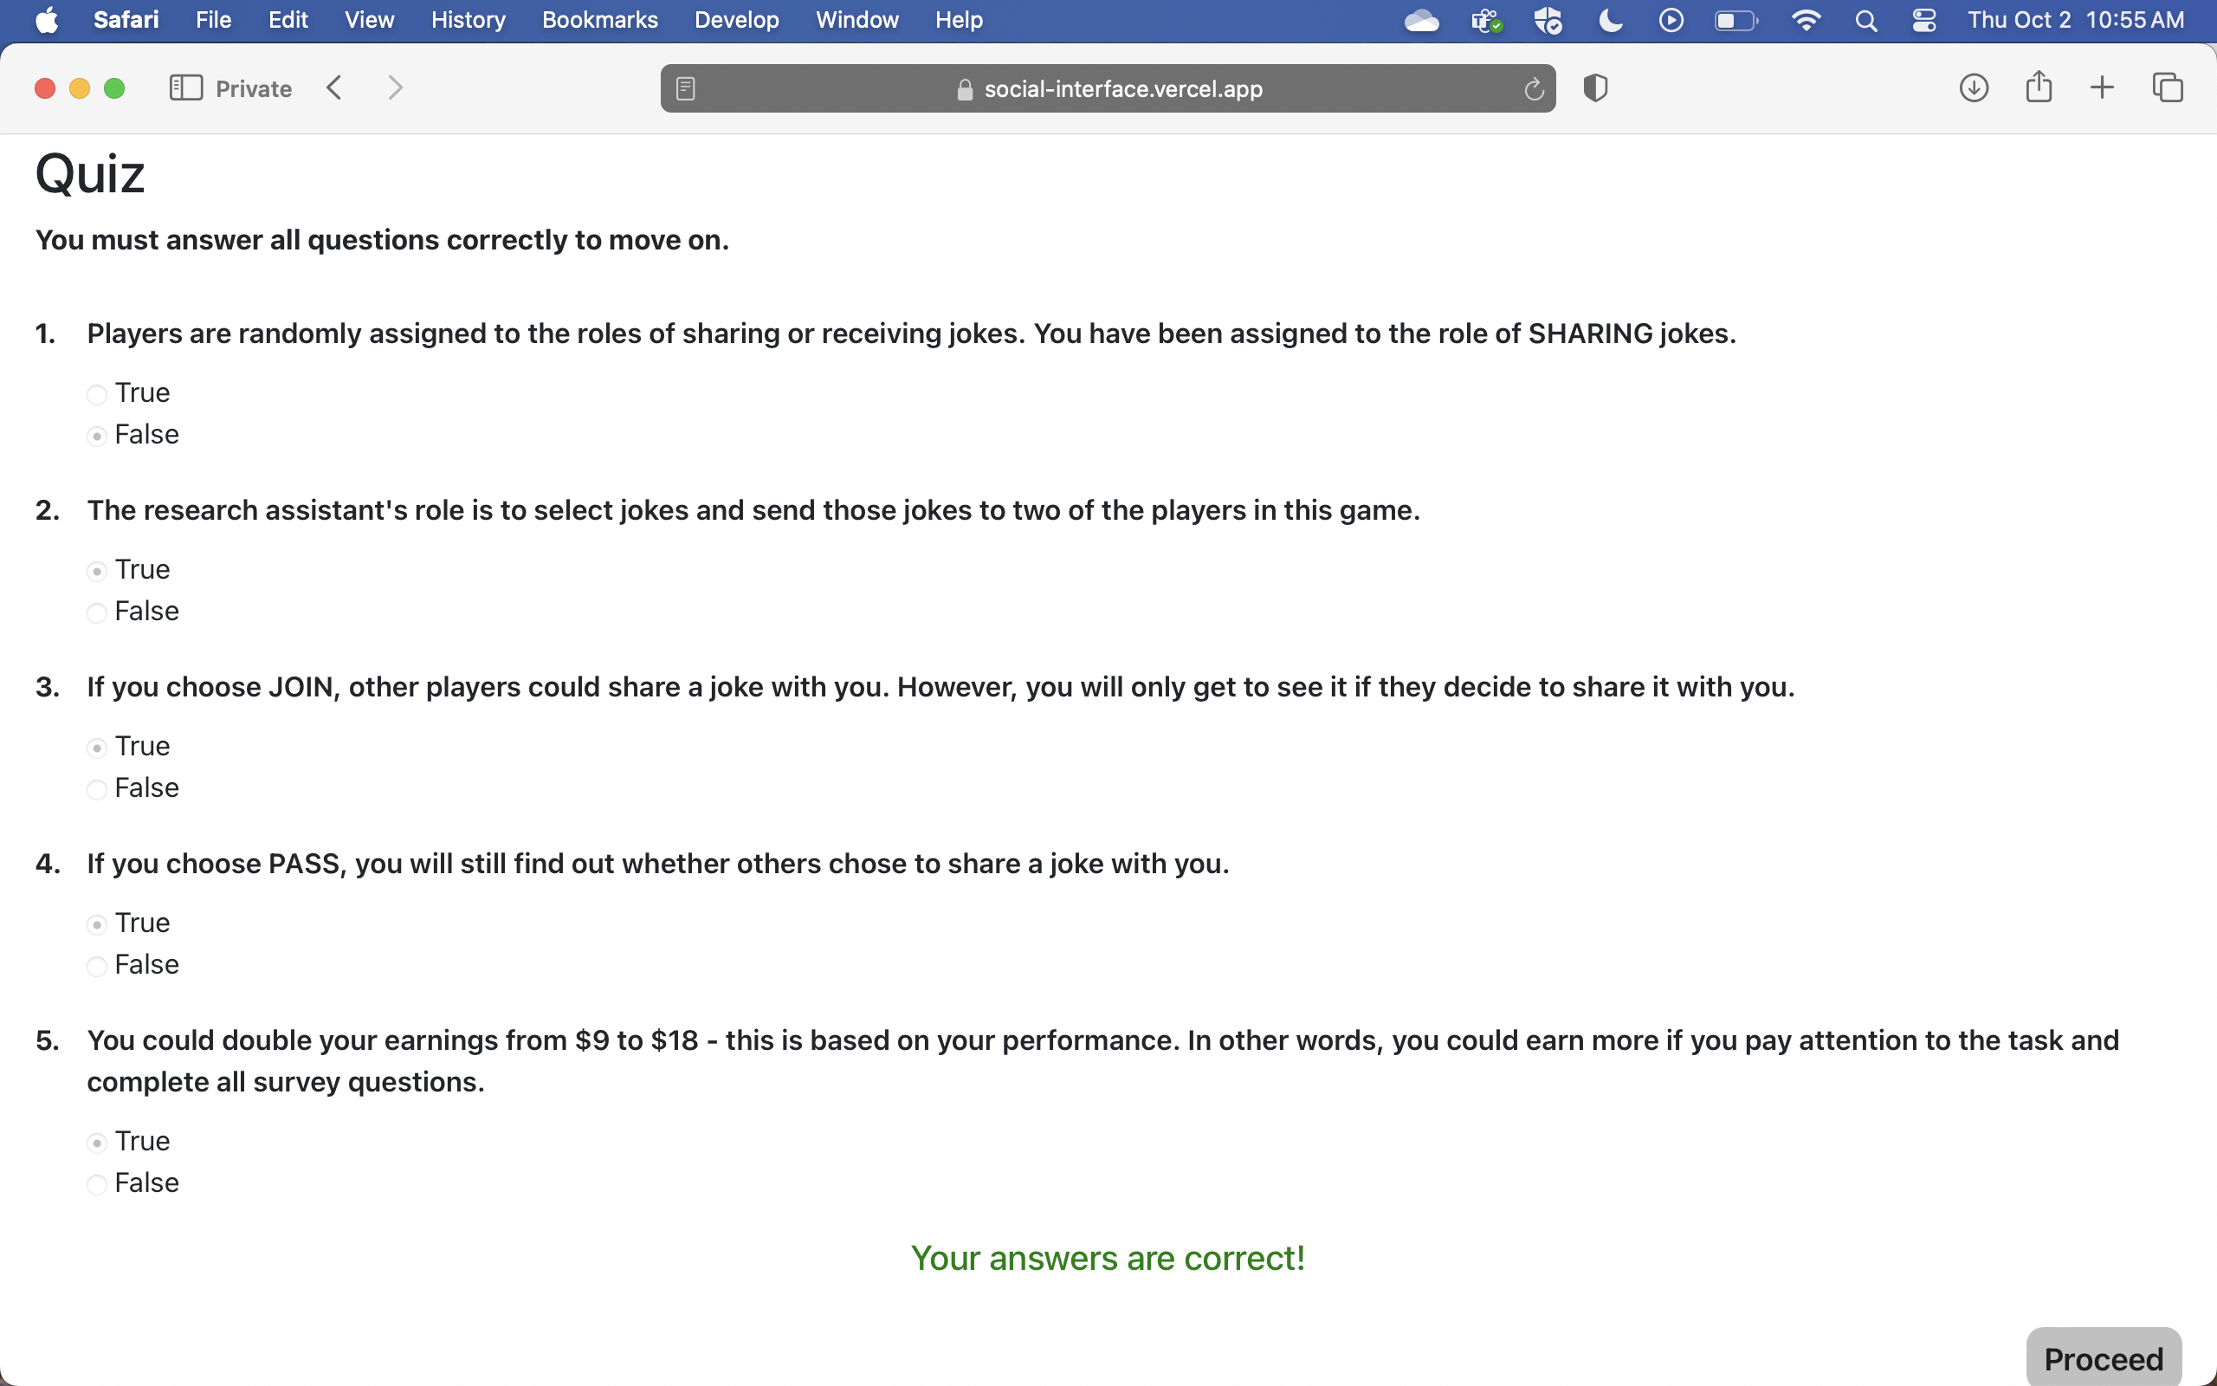

**Entering one or more wrong answers:**

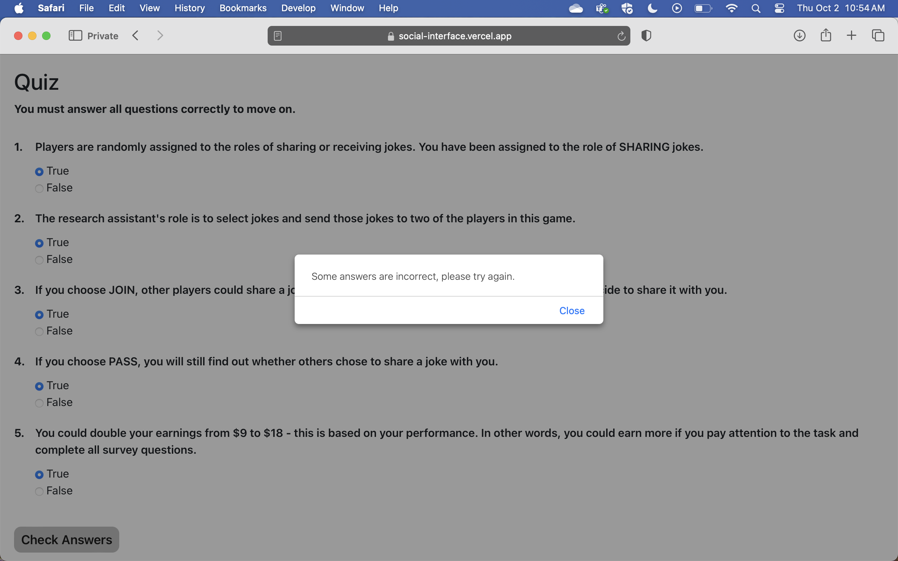

--

*PAGE 5: Beginning of Practice Trials*

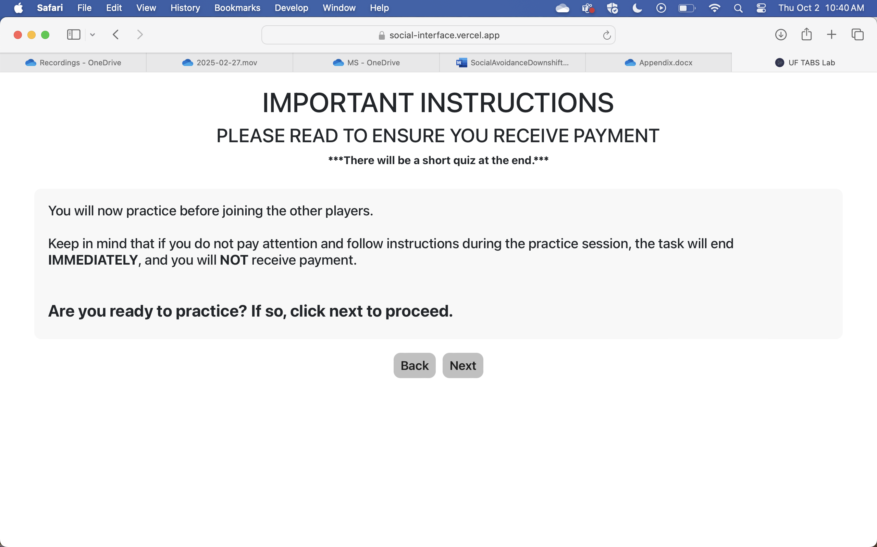

*.*

--

*PAGE 6: PRACTICE TRIAL 1*

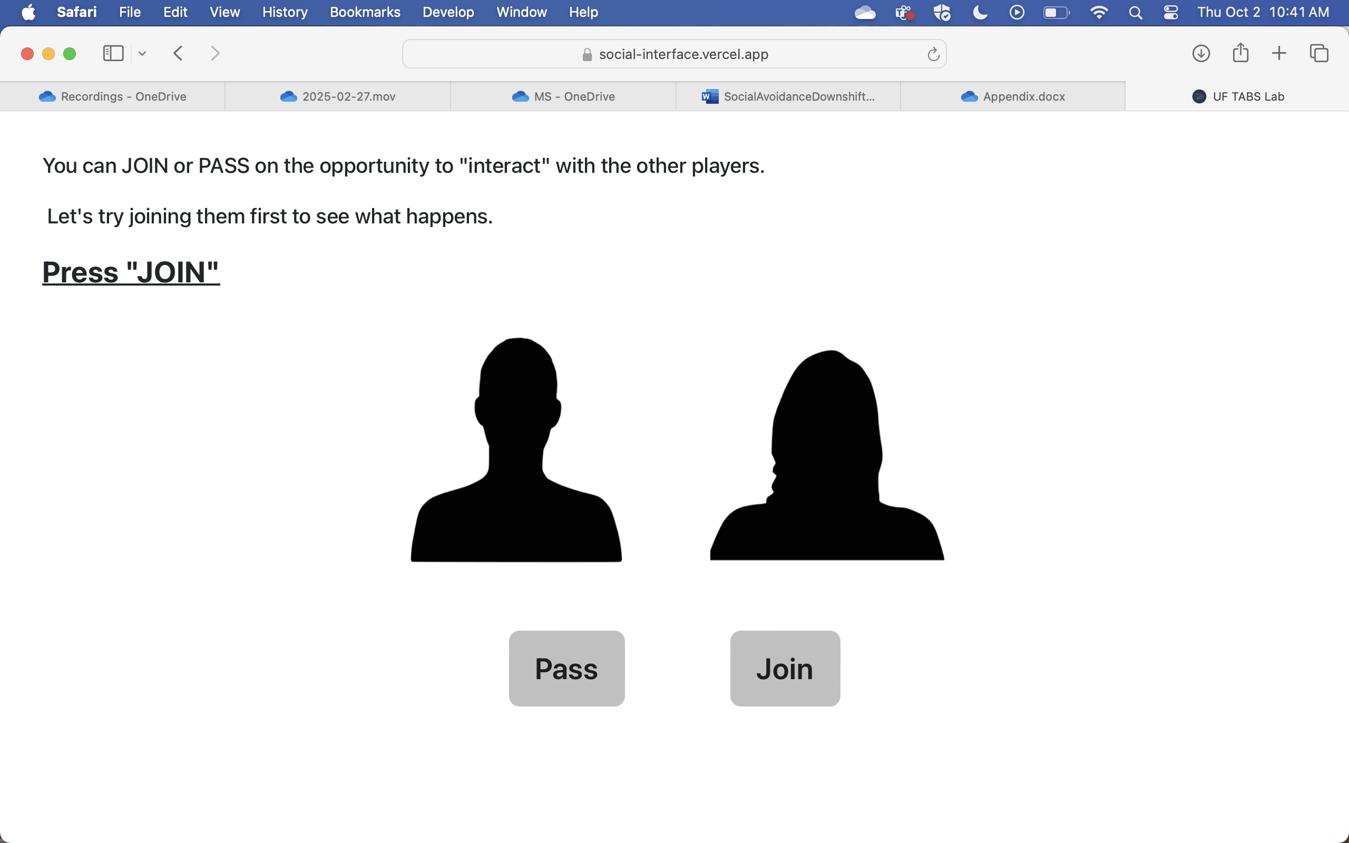

**If participants pressed JOIN:**

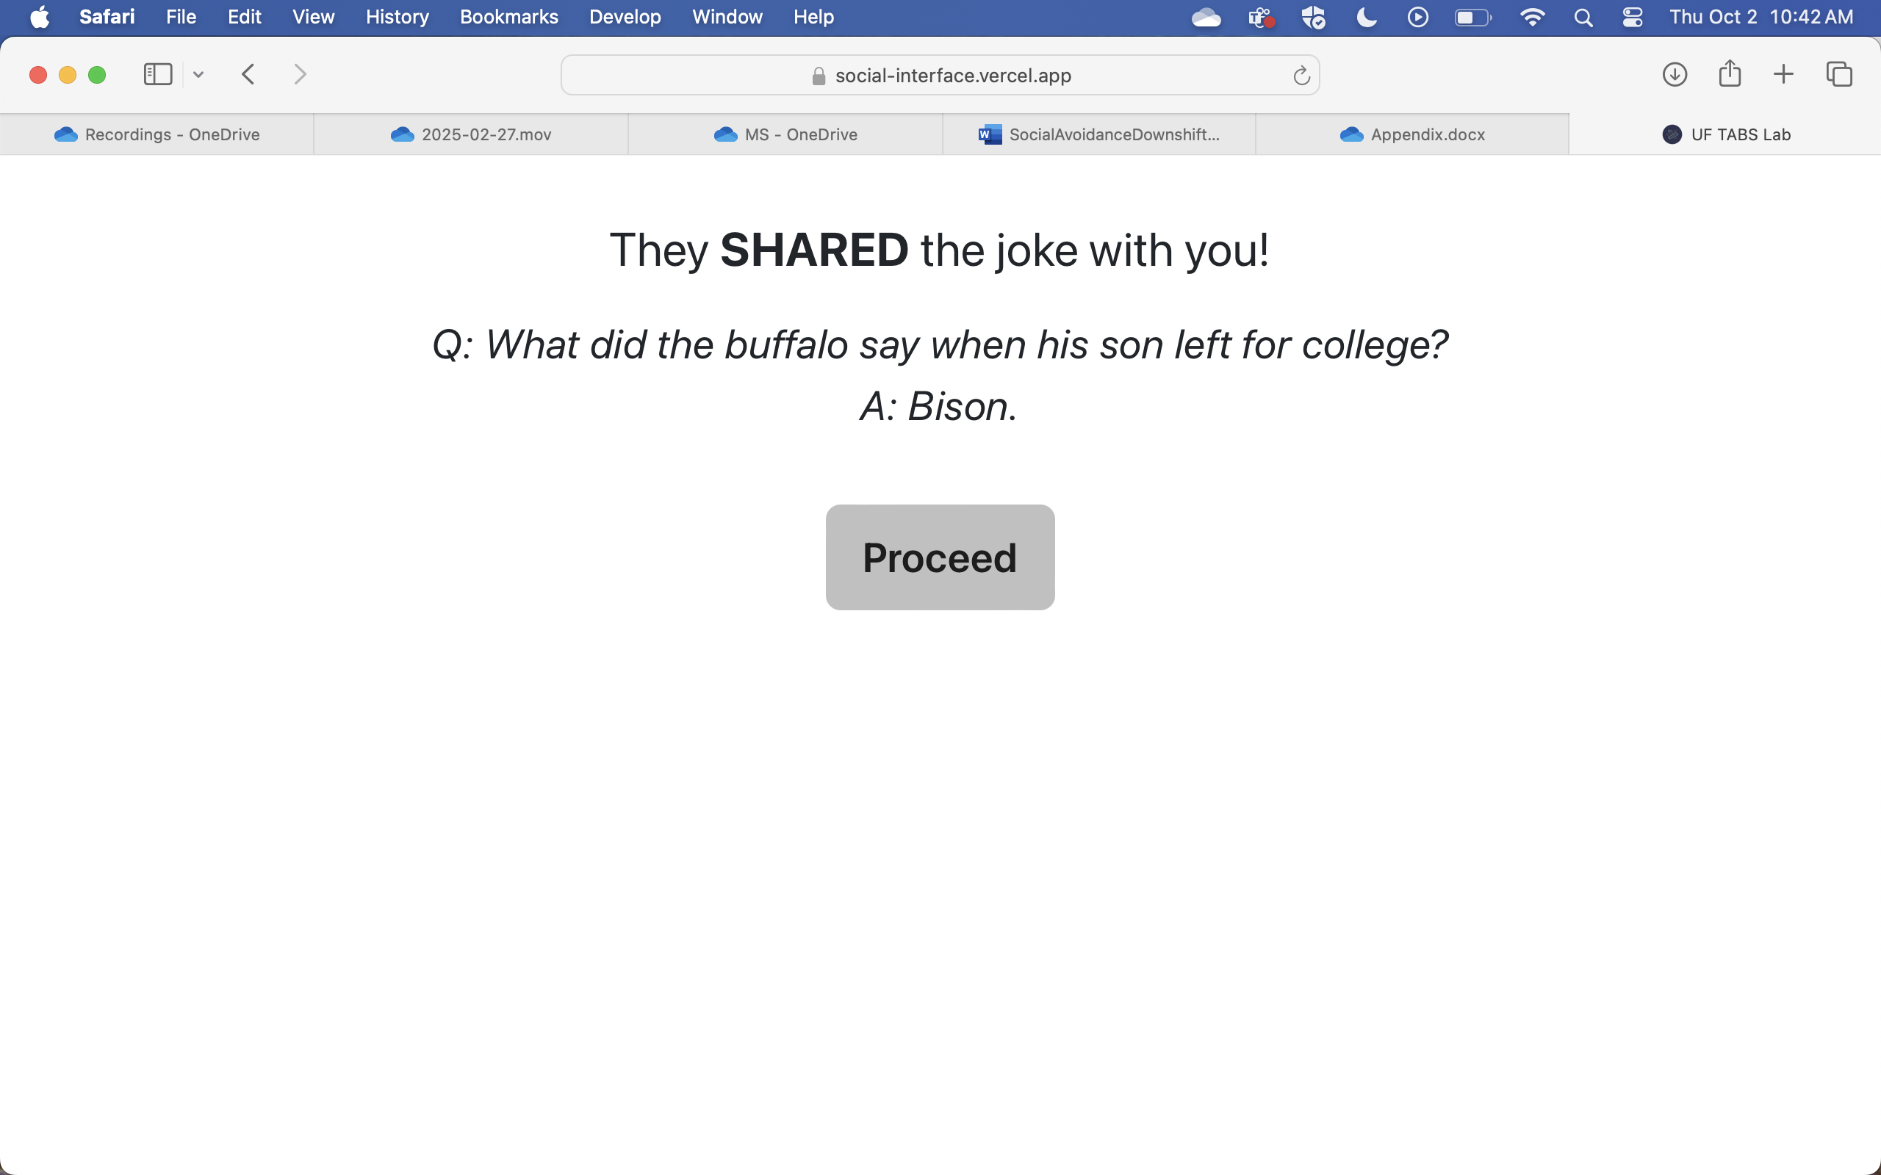

**If participants pressed PASS:**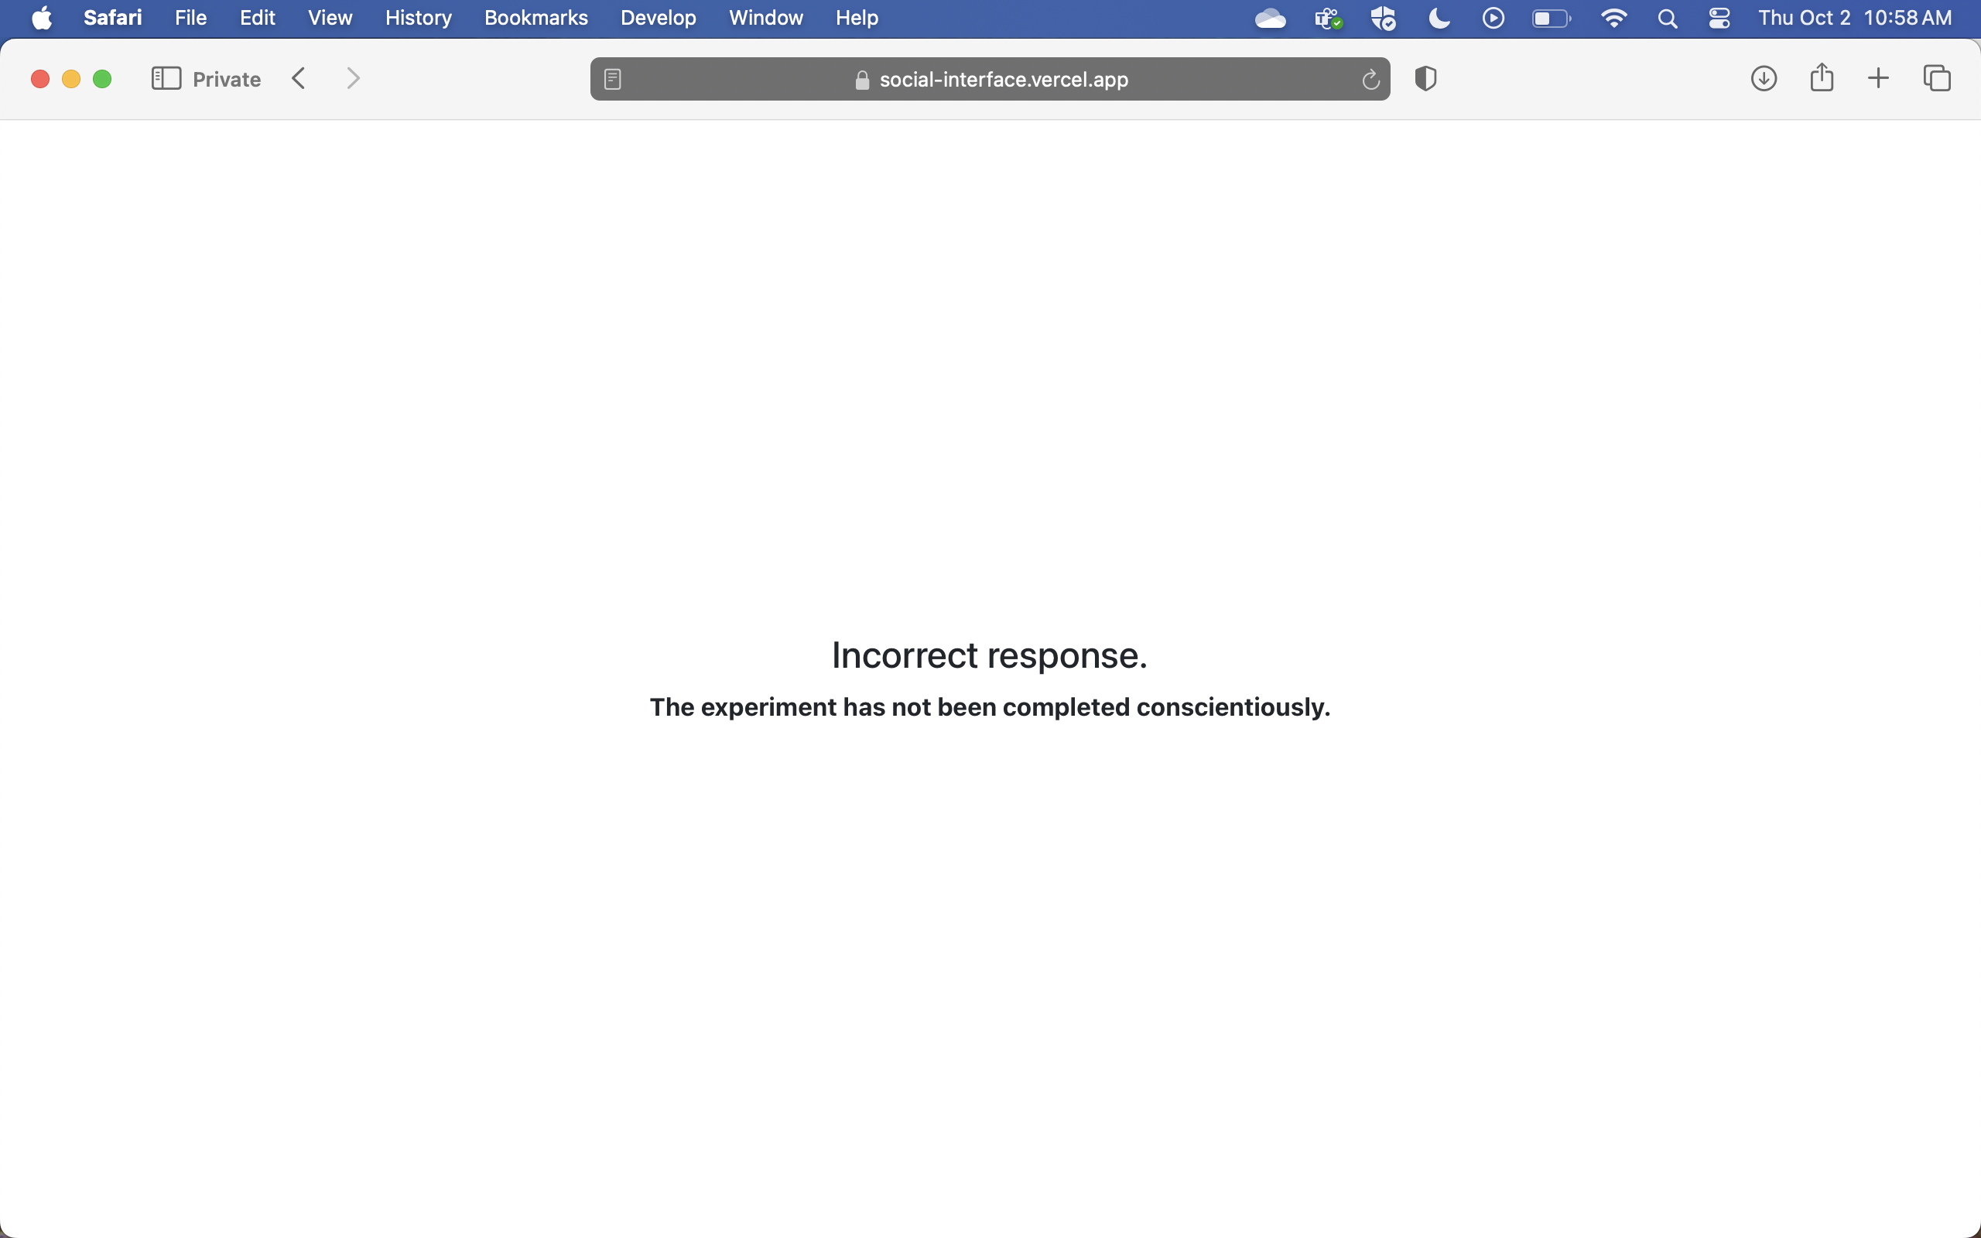

--

*PAGE 7: PRACTICE TRIAL 2*

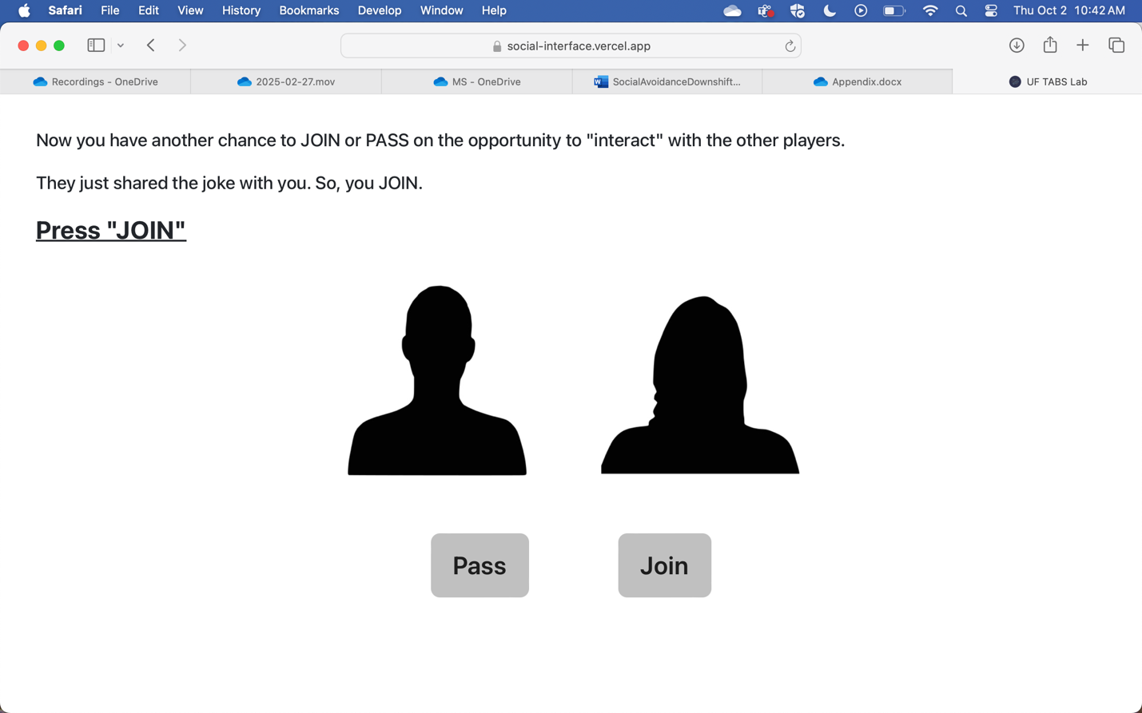

**If participants pressed JOIN:**

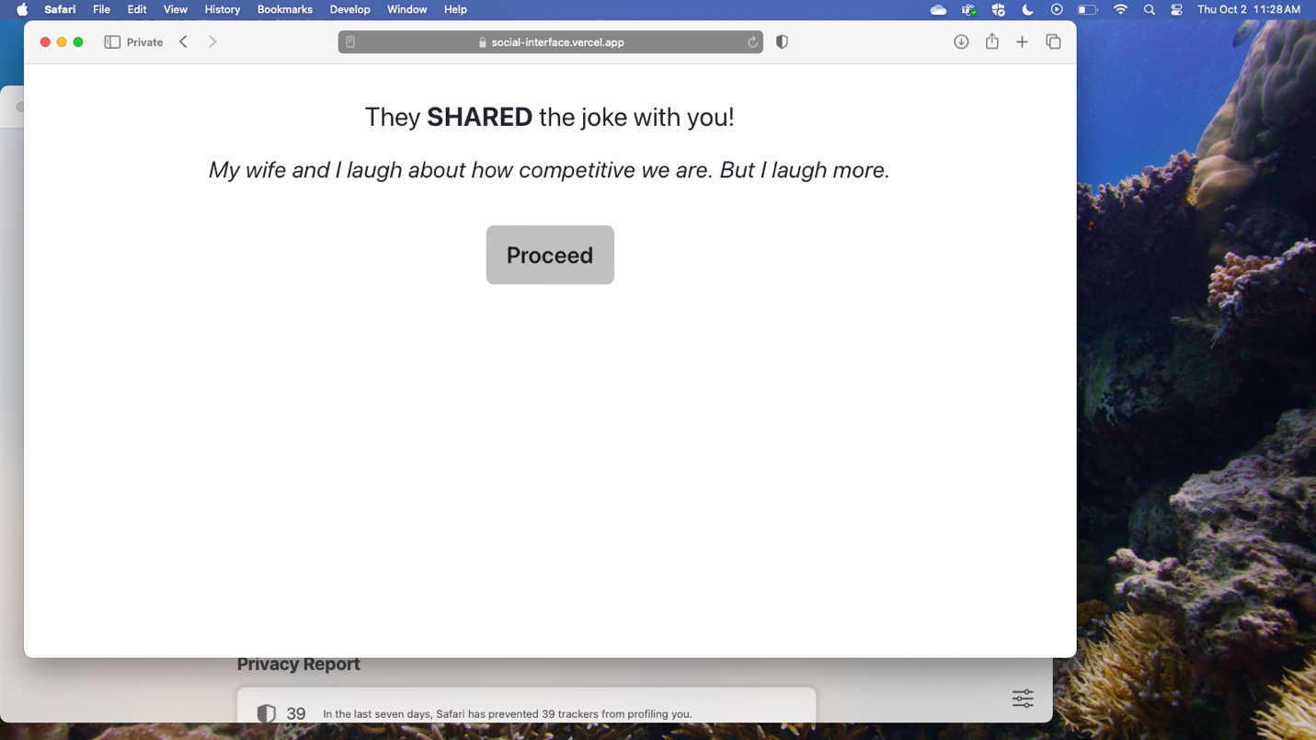

**If participants pressed PASS:**

--

*PAGE 8: PRACTICE TRIAL 3*

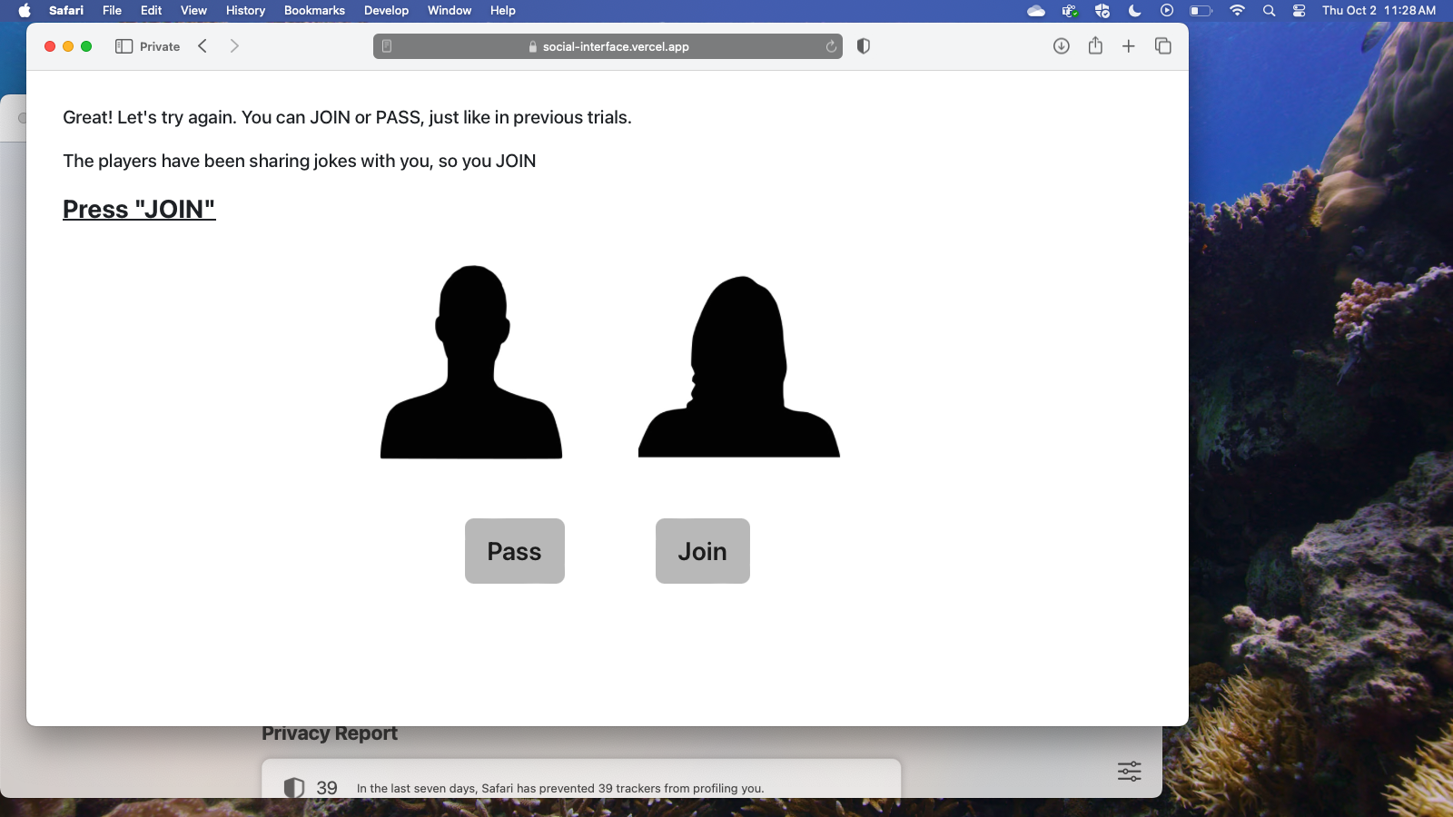

**If participants pressed JOIN:**

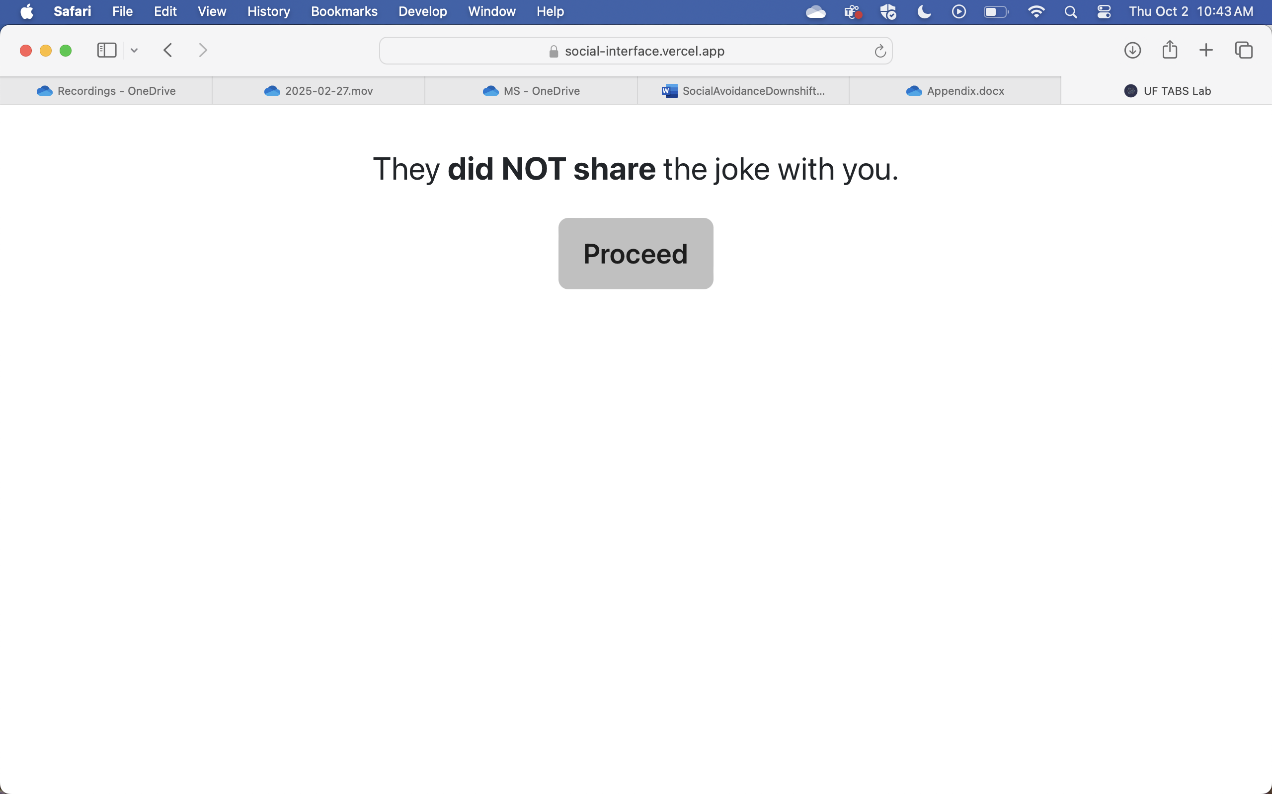

**If participants pressed PASS:**



--

*PAGE 9: PRACTICE TRIAL 4*

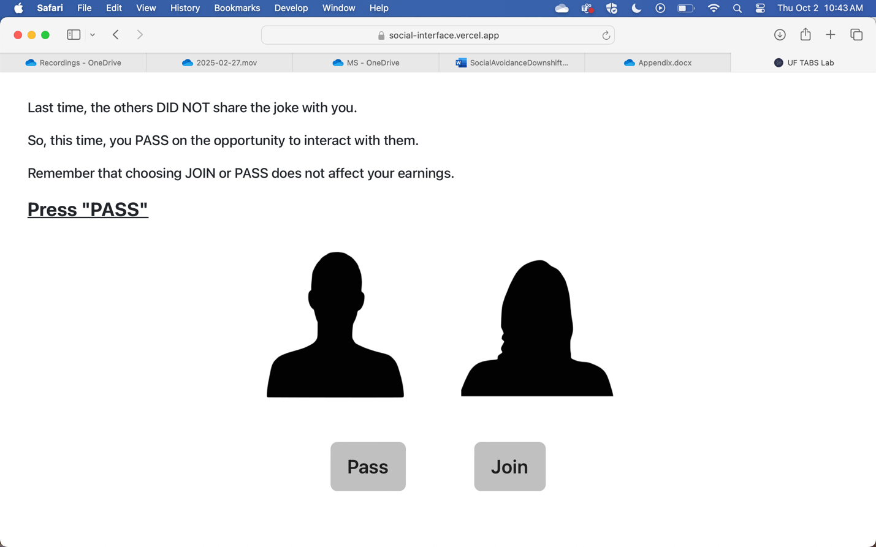

**If participants pressed PASS:**

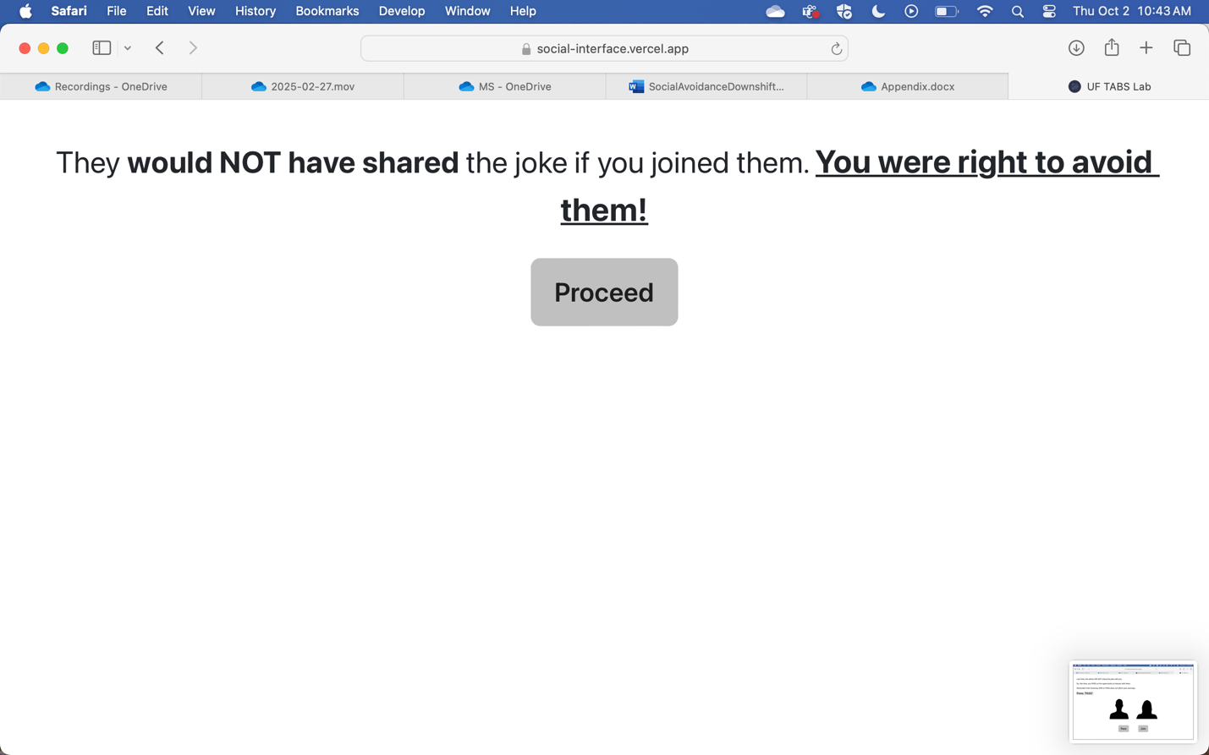

**If participants pressed JOIN:**



--

*PAGE 10: PRACTICE TRIAL 5*

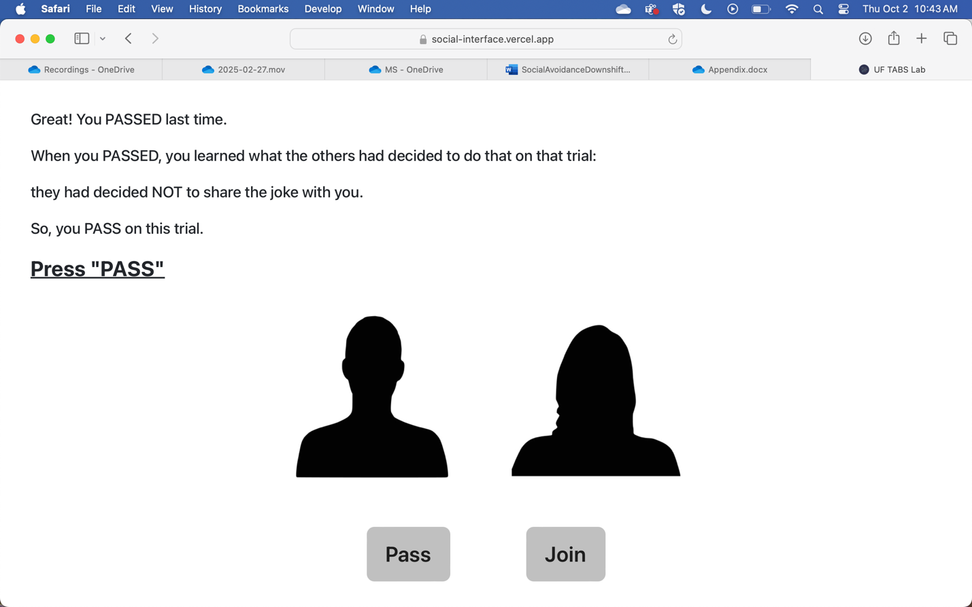

**If participants pressed PASS:**

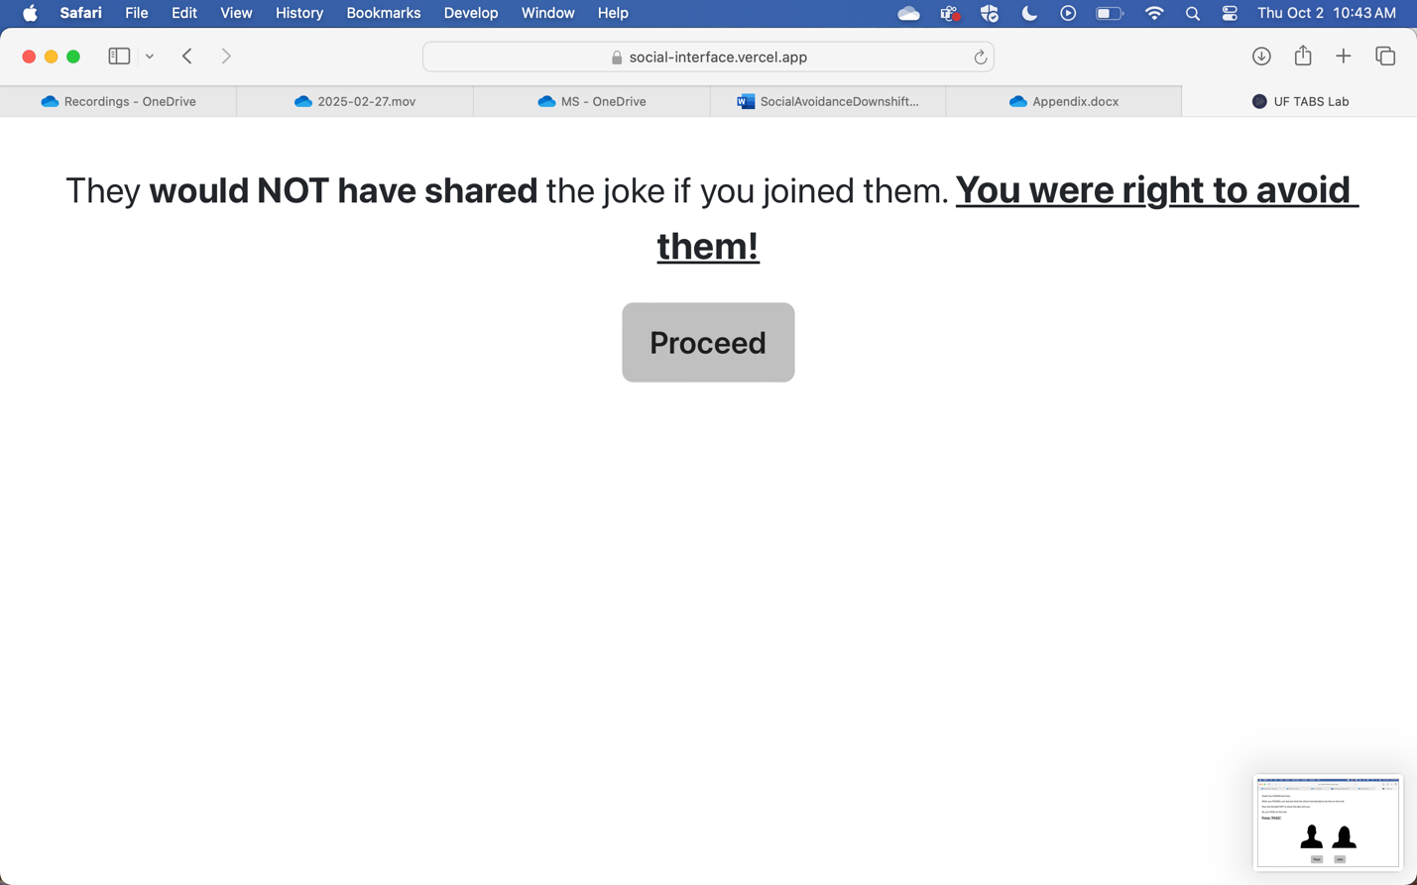

**If participants pressed JOIN:**



--

*PAGE 11: PRACTICE TRIAL 6*

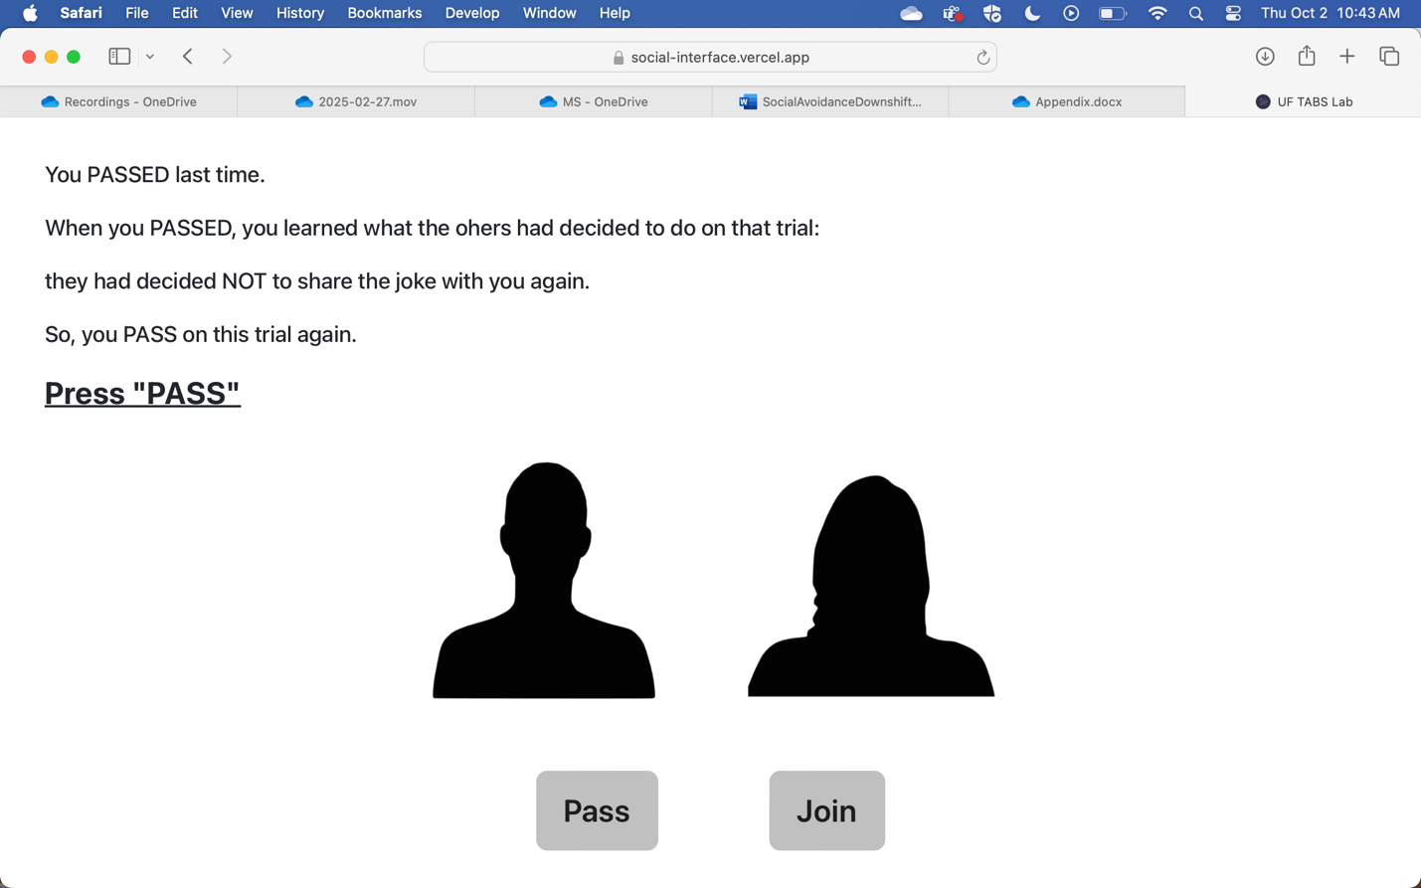

**If participants pressed PASS:**



**If participants pressed JOIN:**



--

*PAGE 12: PRACTICE TRIAL 7*



**If participants pressed PASS:** 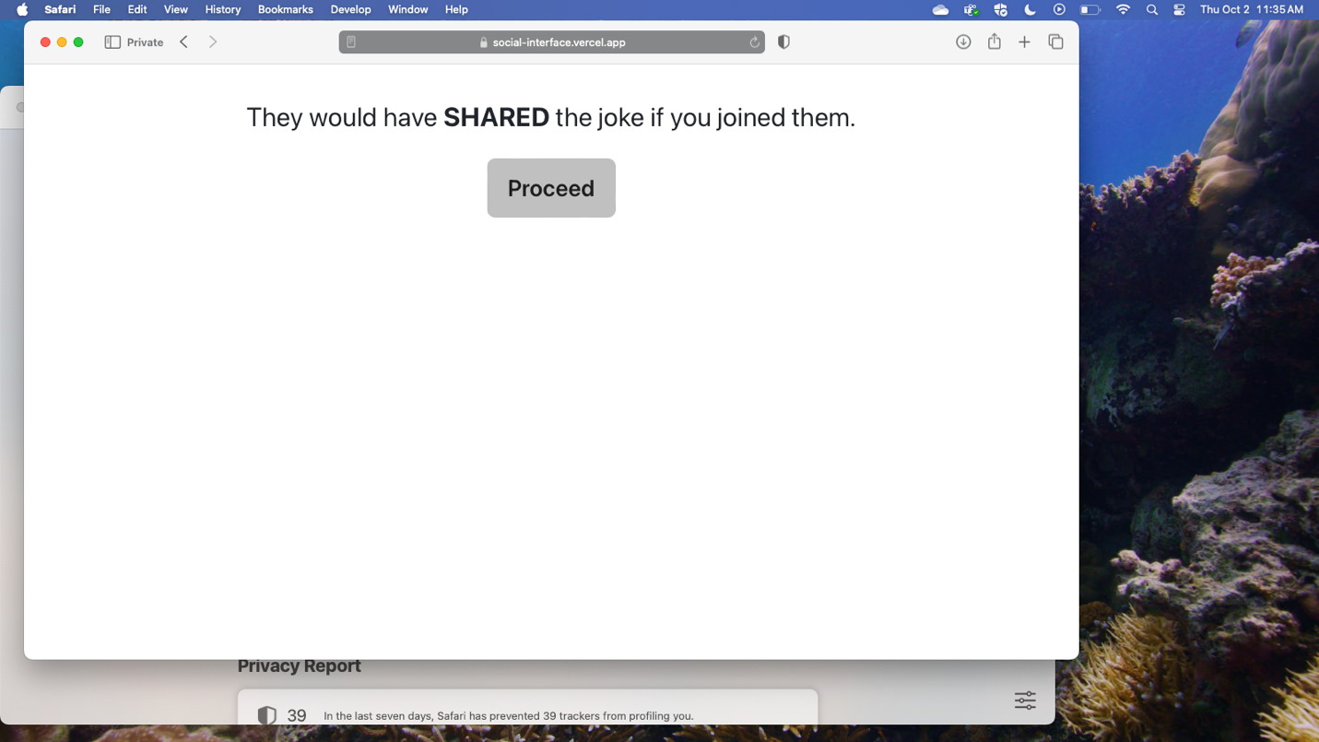

**If participants pressed JOIN:**



--

*PAGE 13: PRACTICE TRIAL 8:*

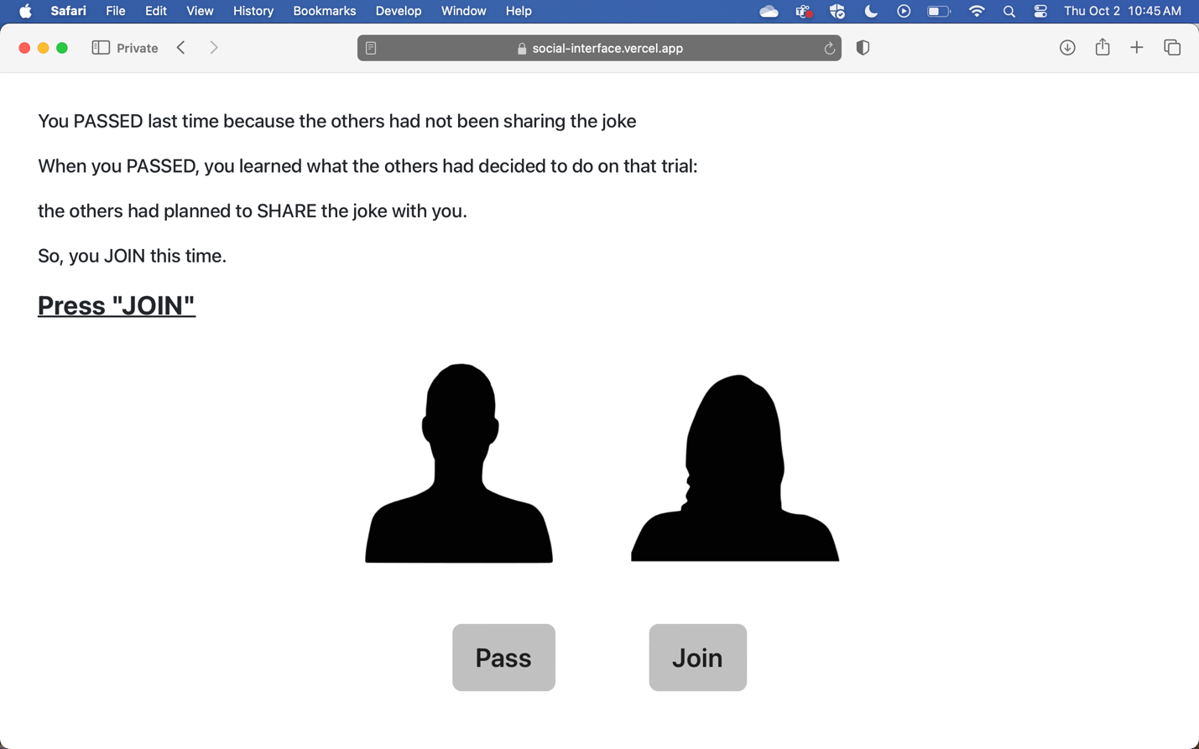

**If participants pressed JOIN:**

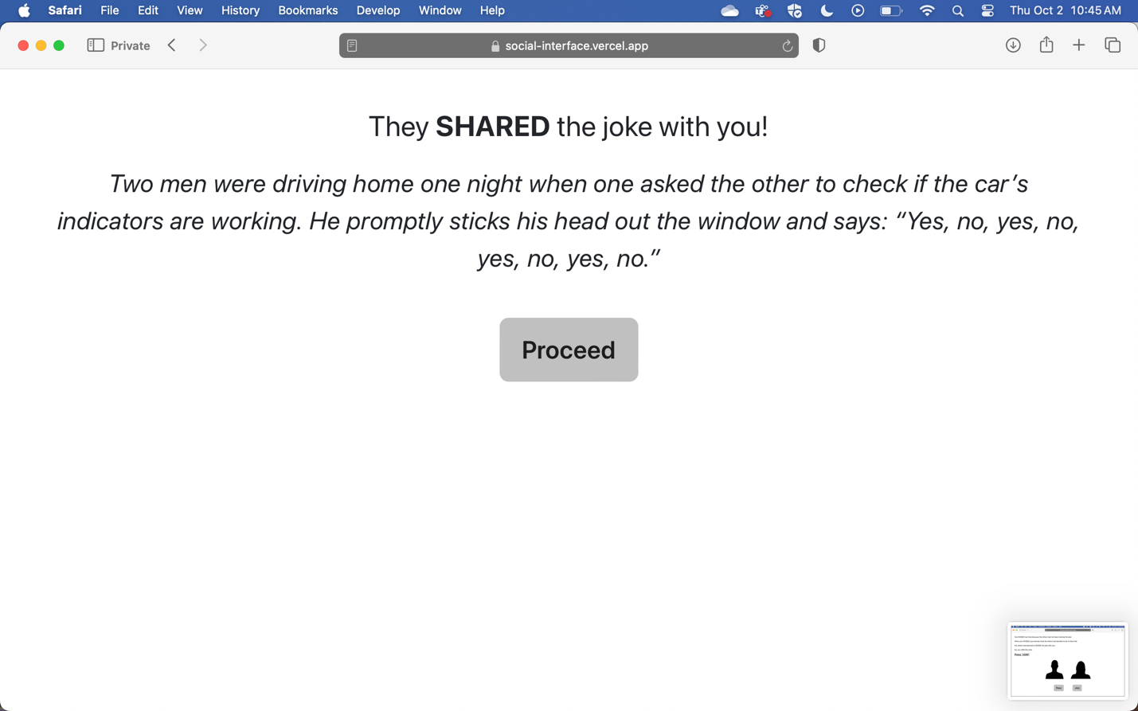

**If participants pressed PASS:**



--

*PAGE 14*

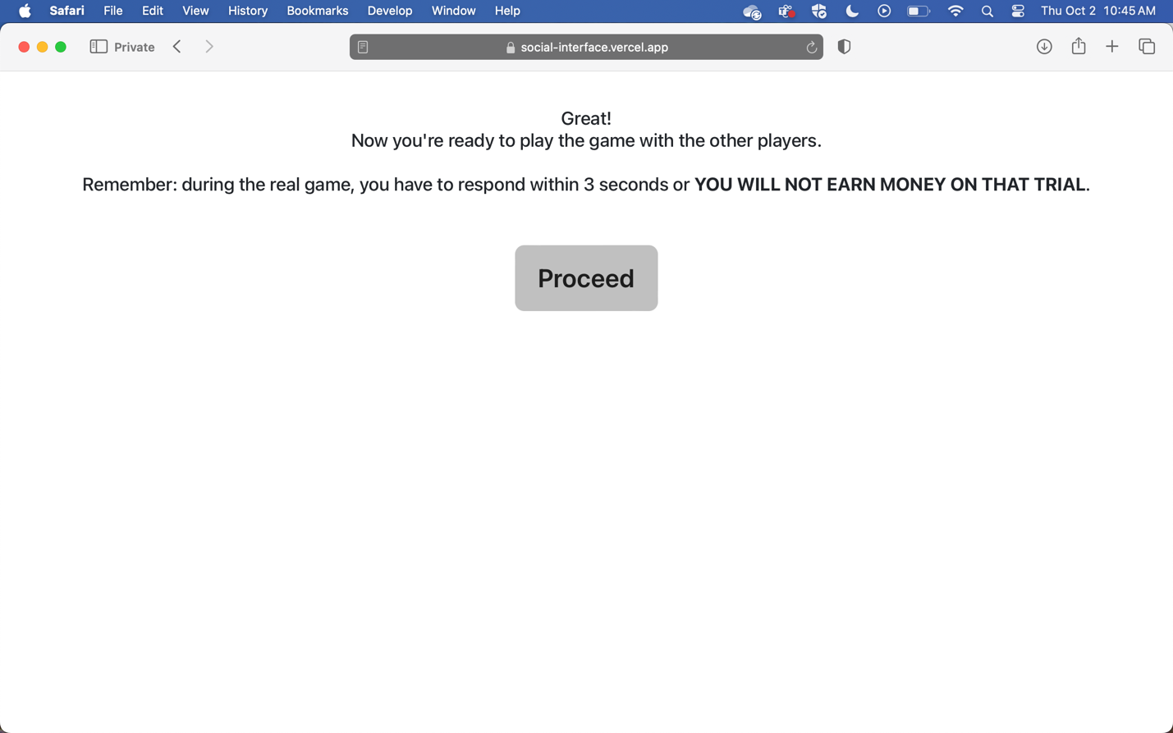

--

*PAGE 15*

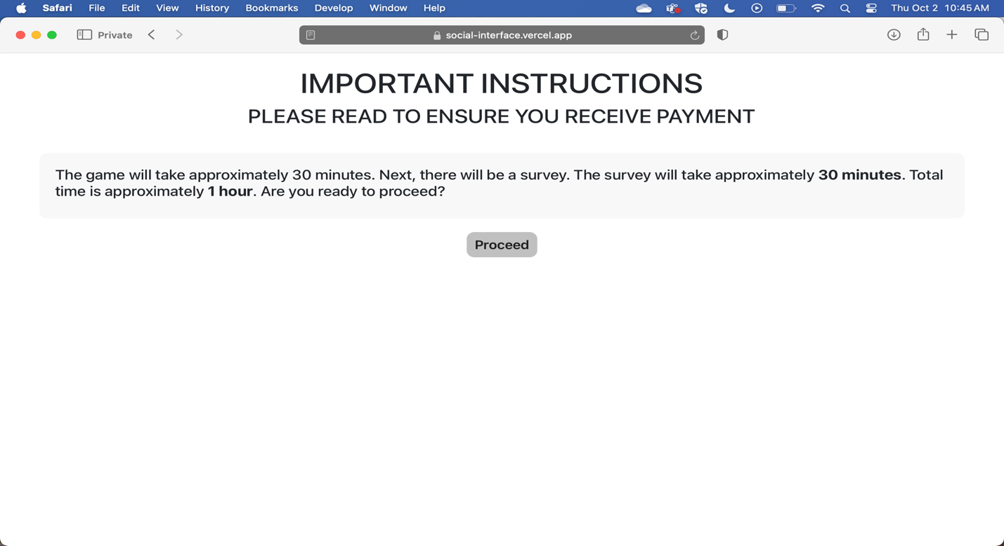

**List of Math Problems for Attention Checks**

1. 0+1
2. 0+2
3. 0+3
4. 0+4
5. 0+5
6. 0+6
7. 0+7
8. 0+8
9. 0+9
10. 1+0
11. 1+1
12. 1+2
13. 1+3
14. 1+4
15. 1+5
16. 1+6
17. 1+7
18. 1+8
19. 2+0
20. 2+1
21. 2+2
22. 2+3
23. 2+4
24. 2+5
25. 2+6
26. 2+7
27. 3+0
28. 3+1
29. 3+2
30. 3+3
31. 3+4
32. 3+5
33. 3+6
34. 4+0
35. 4+1
36. 4+2
37. 4+3
38. 4+4
39. 4+5
40. 5+0
41. 5+1
42. 5+2
43. 5+3
44. 5+4
45. 6+0
46. 6+1
47. 6+2
48. 6+3
49. 7+0
50. 7+1
51. 7+2
52. 8+0
53. 8+1
54. 9+0
55. 1-0
56. 1-1
57. 2-0
58. 2-1
59. 2-2
60. 3-0
61. 3-1
62. 3-2
63. 3-3
64. 4-0
65. 4-1
66. 4-2
67. 4-3
68. 4-4
69. 5-0
70. 5-1
71. 5-2
72. 5-3
73. 5-4
74. 5-5
75. 6-0
76. 6-1
77. 6-2
78. 6-3
79. 6-4
80. 6-5
81. 6-6
82. 7-0
83. 7-1
84. 7-2
85. 7-3
86. 7-4
87. 7-5
88. 7-6
89. 7-7
90. 8-0
91. 8-1
92. 8-2
93. 8-3
94. 8-4
95. 8-5
96. 8-6
97. 8-7
98. 8-8
99. 9-0
100. 9-1
101. 9-2
102. 9-3
103. 9-4
104. 9-5
105. 9-6
106. 9-7
107. 9-8
108. 9-9

**Questionnaires**

Bold titles will not appear in the final version of the questionnaire. *=reverse-scored items.

**Demographic Questions**

1. What is your age?

Sliding scale: 1-99

1. What gender/sex do you identify with?

* Female
* Male
* Other
* I prefer not to answer.

1. What is your race/ethnicity?

* American Indian/Alaska Native
* Asian
* Black/African American
* Hawaiian/Pacific Islander
* Latinx
* White
* Other
* I prefer not to answer.

1. What is your place of birth (country)?

[Short Answer Text Fill]

1. What is the highest level of education you have completed?

* Some high school
* High school diploma
* Some college/vocational training
* College degree
* Professional or graduate degree
* I prefer not to answer.

1. What is your annual household income?

* Less than $25,000
* $25,000 - $50,000
* $50,000 - $100,000
* $100,000 - $200,000
* More than $200,000
* I prefer not to answer.

1. What is your employment status?

* Full-time
* Part-time
* Unemployed but seeking opportunities
* Unemployed (not currently seeking opportunities)
* Retired
* I prefer not to answer.

1. Have you received any clinical diagnoses?

* Depression
* Social anxiety disorder
* Other anxiety disorder
* Autism spectrum disorder
* Attention deficit/hyperactivity disorder
* Other
* I prefer not to answer.

1. Are you currently taking any medications? If yes, please list (medication name(s), dose, frequency).

[Short Answer Text Fill]

**Study Purpose**

1. What do you think was the overall purpose of the study you just completed? If you do not know, please feel free to respond, “I don’t know.” Leave the question blank if you prefer not to answer.

[Short Answer Text Fill]

**Manipulation Check**

1. To what extent were you included by the other players during the game?

Sliding scale: 1=not at all to 9=very much so

[Short Answer Text Fill]

**Social Anxiety (17 questions, ~6 min).** *One purpose of the present study was to examine the relation between social anxiety and resurgence of avoidance. Thus, participants completed the Social Interaction Anxiety Scale (SIAS; Mattick & Clarke, 1998), a widely used measure of social-interaction anxiety with good psychometric properties (e.g., Mattick & Clarke, 1998; Heimberg et al., 1992). Based on recommendations by Rodebaugh et al. (2007), we removed three reverse-scored items, leaving 17 items. Participants evaluated the 17 statements (e.g., “I find myself worrying that I won’t know what to say in social situations”), indicating the extent that each applies to them according to a 5-point Likert scale (0=not at all to 4=extremely). We calculated a total score ranging from 0-68 to provide an overall measure of social-interaction anxiety, with higher scores representing greater anxiety.*

For each item, please circle the number to indicate the degree to which you feel the statement is characteristic or true for you. The rating scale is as follows:

0=Not at all characteristic or true of me.

1=Slightly characteristic or true of me.

2=Moderately characteristic or true of me.

3=Very characteristic or true of me.

4=Extremely characteristic or true of me.

1. I get nervous if I have to speak with someone in authority (teacher, boss, etc.).
2. I have difficulty making eye contact with others.
3. I become tense if I have to talk about myself or my feelings.
4. I find it difficult to mix comfortably with the people I work with.
5. I tense up if I meet an acquaintance in the street.
6. When mixing socially, I am uncomfortable.
7. I feel tense if I am alone with just one other person.
8. I have difficulty talking with other people.
9. I worry about expressing myself in case I appear awkward.
10. I find it difficult to disagree with another’s point of view.
11. I have difficulty talking to attractive persons of the opposite sex.
12. I find myself worrying that I won’t know what to say in social situations.
13. I am nervous mixing with people I don’t know well.
14. I feel I’ll say something embarrassing when talking.
15. When mixing in a group, I find myself worrying I will be ignored.
16. I am tense mixing in a group.
17. I am unsure whether to greet someone I know.

**Depression (7 questions, ~2 min).** *Although social anxiety was of primary interest in the present study, we also evaluated depression given that comorbidity of SAD and depression is high (Kessler et al., 2005). For this purpose, we administered the depression subscale of the Depression, Anxiety and Stress Scale – 21 items (DASS-21; Lovibond & Lovibond, 1995). We selected the DASS-21 due to its brevity and good psychometric properties (see Antony et al., 1998). Using a 4-point Likert scale, participants rated the extent that each item on the DASS-21 applied to them during the past week (e.g., “I felt that I had nothing to look forward to.”; 0=“Did not apply to me at all” and 3=“Applied to me very much or most of the time”). A total score ranging from 0-21 represented increasing levels of depression during the week prior to the study.*

Please read each statement and indicate a number (0, 1, 2 or 3) representing how much the statement applied to you over the past week. There are no right or wrong answers. Do not spend too much time on any statement.

The rating scale is as follows:

0 =Did not apply to me at all

1 =Applied to me to some degree, or some of the time

2 =Applied to me to a considerable degree or a good part of time

3 =Applied to me very much or most of the time

1. I couldn’t seem to experience any positive feeling at all.
2. I found it difficult to work up the initiative to do things.
3. I felt that I had nothing to look forward to.
4. I felt down-hearted and blue.
5. I was unable to become enthusiastic about anything.
6. I felt I wasn’t worth much as a person.
7. I felt that life was meaningless.

**Rejection Sensitivity (18 questions, ~6 min).** *High social anxiety is associated with increased rejection sensitivity (Gutz et al., 2015; Staebler et al., 2011), and rejection sensitivity can moderate behavioral responses to exclusion (e.g., Ayduk et al., 2008; Downey et al. 1998). Thus, we evaluated rejection sensitivity using the Rejection Sensitivity-Adult questionnaire (A-RSQ), an adapted version of the Rejection Sensitivity Questionnaire ([RSQ]; Downey & Feldman, 1996) with good psychometric properties (Berenson et al., 2009). The A-RSQ presents nine scenarios (e.g., “You ask your parents or other family members to come to an occasion that is important to you.”). For each scenario, participants responded on a 6-point Likert scale, indicating their degree of concern or anxiety (e.g., “How concerned or anxious would you be over whether or not they would want to come?”; 1=very unconcerned and 6=very concerned) and expectation of being rejected (e.g., “I would expect they would want to come.”; 1=very unlikely and 6=very likely), with the latter being reverse scored. Rejection sensitivity was calculated as the product of the two measures (range: 1-36), averaged across scenarios, with higher overall scores indicating higher rejection sensitivity.*

The items below describe situations in which people sometimes ask things of others.

For each item, imagine that you are in the situation, and then answer the questions that follow it.

1. You ask your parents or another family member for a loan to help you through a difficult financial time.
   1. How concerned or anxious would you be over whether or not your family would want to help you?
   2. *I would expect that they would agree to help as much as they can.
2. You approach a close friend to talk after doing or saying something that seriously upset him/her.
   1. How concerned or anxious would you be over whether or not your friend would want to talk with you?
   2. *I would expect that he/she would want to talk with me to try to work things out.
3. You bring up the issue of sexual protection with your significant other and tell him/her how important you think it is.
   1. How concerned or anxious would you be over his/her reaction?
   2. *I would expect that he/she would be willing to discuss our possible options without getting defensive.
4. You ask your supervisor for help with a problem you have been having at work.
   1. How concerned or anxious would you be over whether or not the person would want to help you?
   2. *I would expect that he/she would want to try to help me out.
5. After a bitter argument, you call or approach your significant other because you want to make up.
   1. How concerned or anxious would you be over whether or not your significant other would want to make up with you?
   2. *I would expect that he/she would be at least as eager to make up as I would be.
6. You ask your parents or other family members to come to an occasion important to you.
   1. How concerned or anxious would you be over whether or not they would want to come?
   2. *I would expect that they would want to come.
7. At a party, you notice someone on the other side of the room that you’d like to get to know, and you approach him or her to try to start a conversation.
   1. How concerned or anxious would you be over whether or not the person would want to talk with you?
   2. *I would expect that he/she would want to talk with me.
8. Lately you’ve been noticing some distance between yourself and your significant other, and you ask him/her if there is something wrong.
   1. How concerned or anxious would you be over whether or not he/she still loves you and wants to be with you?
   2. *I would expect that he/she will show sincere love and commitment to our relationship no matter what else may be going on.
9. You call a friend when there is something on your mind that you feel you really need to talk about
   1. How concerned or anxious would you be over whether or not your friend would want to listen?
   2. *I would expect that he/she would listen and support me.

**Fundamental Psychological Needs (13 items, ~4 min).** *Many studies have evaluated effects of exclusion on emotional distress, including threats to fundamental psychological needs (i.e., need threat; see Gerber & Wheeler, 2009; Hartgerink et al., 2015, for reviews). In line with this approach, we included a modified version of a need-threat questionnaire (NTQ; Zadro et al., 2004) – see Appendix D for details. The scale has reasonable construct validity (Gerber et al., 2017) and reliably differentiates needs across groups experiencing inclusion or exclusion (e.g., Hartgerink et al., 2015). The need-threat measure includes 12 questions measuring sense of belonging (e.g., “I felt like an outsider during the game.”), self-esteem (e.g., “I felt somewhat inadequate during the game.”), meaningful existence (e.g., “I felt non-existent during the game.”), and control (e.g., “I felt in control during the game.”). Each item was rated on a 9-point Likert scale (1=not at all and 9=very much so). Items were reverse scored as necessary, resulting in a total NTQ score ranging from 12-108; lower versus higher scores indicated greater need threat or fulfilment, respectively. Questions were modified as indicated below to reflect the current procedures.*

*1. I felt poorly accepted by the other ~~participants~~ players.

2. I felt as though I had made a “connection” or bonded with one or more of the ~~participants~~ players during the ~~Cyberball~~ game.

*3. I felt like an outsider during the ~~Cyberball~~ game.

4. I felt that I was able to ~~throw the ball~~ see jokes with others as often as I wanted during the game.

*5. I felt somewhat frustrated during the ~~Cyberball~~ game.

6. I felt in control during the ~~Cyberball~~ game.

7. During the ~~Cyberball~~ game‚ I felt good about myself.

*8. I felt that the other ~~participants~~ players failed to perceive me as a worthy and likeable person.

*9. I felt somewhat inadequate during the ~~Cyberbal~~l game.

10. I felt my ~~performance [e.g.‚ catching the ball‚ deciding whom to throw the ball to]~~ choices had some effect on the direction of the game.

*11. I felt non-existent during the ~~Cyberbal~~l game.

*12. I felt as though my existence was meaningless during the ~~Cyberball~~ game

**Background Social Support (5 questions, ~2 min).** *Like rejection sensitivity, social support can moderate behavioral responses to exclusion (Twenge et al., 2007). To evaluate background social support, we included brief version of the Social Provisions Scale (SPS; Cutrona & Russell, 1987; e.g., Dinh et al., 2021). The brief version contains five items and demonstrates good psychometric properties (Orpana et al., 2019). Each question addresses one of five different social needs, as outlined by Weiss (1974), including guidance (“There is someone I could talk to about important decisions in my life.”), reliable alliance (“There are people I can count on in an emergency.”), reassurance of worth (“I have relationships where my competence and skills are recognized.”), attachment (“I have close relationships that provide me with a sense of emotional security and well-being.”), and social integration (“I feel part of a group of people who share my attitudes and beliefs.”). Items were rated on a 4-point Likert scale (1=strongly disagree and 4=strongly agree). We calculated an overall score by summing responses from the five questions (range=5 to 20), with higher scores indicating higher levels of social support.*

1. I have close relationships that provide me with a sense of emotional security and well-being.
2. There is someone I could talk to about important decisions in my life.
3. I have relationships where my competence and skills are recognized.
4. I feel part of a group of people who share my attitudes and beliefs.
5. There are people I can count on in an emergency.

**Exclusion Criteria**

Groups 60-20 experienced availability of social reinforcement versus extinction on 40 of 60 Phase-2 trials. Group 60-60 experienced continuous availability of social reinforcement in Phase 2. However, Group 60-20 demonstrated less avoidance than Group 60-60 by the end of Phase 2 (e.g., Figure 5, Trial Blocks 24). With respect to JOIN responses, this suggests that intermittent reinforcement for JOIN resulted in *more* choices of JOIN over PASS relative to continuous reinforcement. Thus, we examined whether these differences between Group 60-20 and Group 60-60 might have occurred due to a disproportionately high number of participants demonstrating insensitivity to the arranged contingencies in Group 60-60. To test this possibility, we revised exclusion criteria as follows: rather than removing data sets with only one type of response across all 180 trials (e.g., Zabag et al., 2022), we removed data sets with only one type of response for the last 121 trials (beginning with the last Phase-1 trial). For example, this less stringent criterion would remove data from participants who showed some variability in their choices in Phase 1, but never deviated from avoidance after Phase 1[1]. The revised exclusion criterion resulted in removal of nine additional data sets, including four each in Groups 60-60 and 60-20, and one in Group 60-40. Figure S1 shows the results as a revised version of Figure 2, and Table S1 shows revised mean percentages with avoidance in the last 5-trial block of Phase 2.

No additional data sets were removed from Group 60-20 (*M*=20.48, *SEM*=4.98). Relative to Group 60-20, the mean percentage of trials with avoidance was higher in Group 60-60 with (*M*=30, *SEM*=7.10) and without the revised criteria (*M*=37, *SEM*=7.22). Overall, this suggests that the difference among groups was not solely a function of the distribution of participants who were insensitive to the contingencies.

**Table S1**

*Mean Percentage of Avoidance Responses in the Last 5-Trial Block of Phase 2: Comparison of Two Exclusion Criteria*

|  |  |  |  |  |
| --- | --- | --- | --- | --- |
| **Group** | **Original Exclusion Criteria** | | **Revised Criteria** | |
|  | n | Mean (SEM) | n (Number of Additional Exclusions) | Mean (SEM) |
| 60-60 | 40 | 37.00 (7.22) | 36 (4) | 30.00 (7.10) |
| 60-20 | 42 | 20.48 (4.98) | 42 (0) | 20.48 (4.98) |
| 60-40 | 40 | 49.50 (6.91) | 39 (1) | 48.21 (6.96) |
| 60-0 | 41 | 80.00 (4.99) | 37 (4) | 77.84 (5.14) |

*Note.* Original Exclusion Criteria: 1. Only one type of response (JOIN or PASS) across all 180 trials. 2. Missing responses – i.e., no responses on 30 or more trials or no survey data. Total exclusions=15 (8.4%). Revised Criteria: Includes original criteria and a revision to #1: only one type of response (JOIN or PASS) across the last **120** trials (i.e., beginning in Phase 2). Total exclusions=24 (13.5%).

**Figure S1**

*Revision of Figure 2 with New Exclusion Criteria*

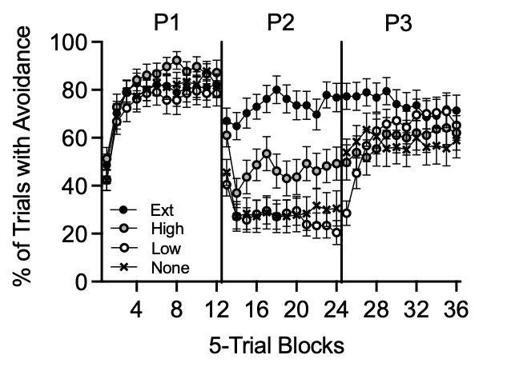

*Note.* The figure shows mean percentage of 5-trial blocks with avoidance (PASS). P1=Phase 1; P2=Phase 2; P3=Phase 3. An additional nine data sets were removed relative to Figure 2: four each from Groups 60-60 and 60-0, and one from Group 60-40. We removed data with only one type of response (JOIN or PASS) across the last 120 (versus all 180) trials.

**Mixed-Effects Regression**

**Primary Analysis:**

The final model included random effects of Trial, Phase, and an interaction between Trial and Phase; fixed effects included Trial, Phase, Group, and all possible interactions among those variables (see Table S2). Phase (2) and Group (60-60) factors were used as points of comparison.

Phases 1 and 2. The interaction between Phase 1 and Group 60-20 (Line 9) indicated different effects of Phase 1 versus 2 in Group 60-20 relative to Group 60-60. Similarly, there was a significant interaction of Trial and Group 60-20 (Line 7), indicating differences in how the likelihood of avoidance changed across trials in Group 60-20 relative to Group 60-60.

**Phases 2 and 3**. The interaction between Phase 3 and Group 60-0 (Line 8) indicated different effects of Phase 3 versus 2 in Group 60-0 relative to Group 60-60. In line with this finding, Figure 2 shows avoidance was low in each group in Phase 2 but higher in Group 60-0 versus 60-60 in Phase 3 (see also Figure 4).

Pairwise comparisons revealed significant three-way interactions between Trial, Phase 3, and Group 60-0 (Line 10) and between Trial, Phase 3, and Group 60-20 (Line 11). Generally, these three-way interactions indicated differences in the interaction between Trial and Phase 3 – i.e., how the likelihood of avoidance changed across trials in Phase 3 relative to Phase 2 – in Groups 60-0 and 60-20 relative to 60-60.

Within-group comparisons indicated significant increases in the likelihood of avoidance from the end of Phase 2 to the halfway point of Phase 3 (Trial 150) in Groups 60-20 (*z*=2.56, *p*=.010) and 60-0 (*z*=5.87, *p*<.001) but not for Groups 60-40 and 60-60 (*p*s>.803). In other words,

Additional between-group comparisons further elucidated differences in the overall likelihood of avoidance at the halfway point of Phase 3. At that time point, the likelihood of avoidance was higher in Group 60-0 relative to all other groups (*z*s>2.11, *p*s<.047), and in Group High versus both 60-40 and 60-60 (*z*s>2.29, *p*s<.047). The likelihood of avoidance was also higher in Group 60-40 versus 60-60 (*z*=2.42, *p*=.047).

**Exploratory Analysis:**

Given that contingencies differed among groups in Phase 3, we also examined whether social anxiety was correlated with avoidance as a proportion of all Phase-3 trials in specific groups (60-40 and 60-60, 60-20 and 60-0), but these correlations were not significant (*p*s>.448). We also examined whether social anxiety was correlated with avoidance during the first half of trials in Phase 3 both overall and within specific groups (60-40 and 60-60, 60-20 and 60-0). However, none of these correlations were significant (*p*s>.526).

**Table S2**

*Results of Mixed-Effects Regression Examining the Influence of Group, Phase, and Trial on Choice*

|  |  |  |  |  |  |
| --- | --- | --- | --- | --- | --- |
| Fixed effect | Estimate (SE) | Odds  Ratio | Probability | *z* | *p* |
| Intercept | 2.27 (0.45) | 9.67 | 0.91 | 5.06 | <.001*** |
| Trial | -0.05 (0.01) | 0.95 | 0.49 | -6.62 | <.001*** |
| Phase (1) | -2.54 (0.46) | 0.08 | 0.07 | -5.51 | <.001*** |
| Phase (3) | -0.96 (1.00) | 0.38 | 0.28 | -0.96 | .339 |
| Group (60-0) | 1.01 (0.67) | 2.75 | 0.73 | 1.52 | .129 |
| Group (60-40) | -1.97 (0.60) | 0.14 | 0.12 | -3.26 | .001** |
| Group (60-20) | -0.52 (0.62) | 0.60 | 0.37 | -0.83 | .405 |
| Trial * Phase (1) | 0.25 (0.03) | 1.28 | 0.56 | 8.13 | <.001*** |
| Trial * Phase (3) | -0.42 (0.21) | 0.66 | 0.40 | -1.98 | .048* |
| Trial * Group (60-0) | -0.01 (0.01) | 0.99 | 0.50 | -1.15 | .250 |
| Trial * Group (60-40) | 0.03 (0.01) | 1.03 | 0.51 | 3.01 | .003** |
| Trial * Group (60-20) | 0.01 (0.01) | 1.01 | 0.50 | 0.84 | .404 |
| Phase (1) * Group (60-0) | -0.76 (0.69) | 0.47 | 0.32 | -1.12 | .265 |
| Phase (3) * Group (60-0) | -6.75 (1.31) | 1.17E-3 | 1.17E-3 | -5.16 | <.001*** |
| Phase (1) * Group (60-40) | 2.30 (0.62) | 9.98 | 0.91 | 3.69 | <.001*** |
| Phase (3) * Group (60-40) | 1.18 (1.17) | 3.25 | 0.76 | 1.01 | .314 |
| Phase (1) * Group (60-20) | 0.67 (0.64) | 1.96 | 0.66 | 1.05 | .292 |
| Phase (3) * Group (60-20) | -0.43 (1.27) | 0.65 | 0.39 | -0.34 | .732 |
| Trial * Phase (1) * Group (60-0) | -0.01 (0.04) | 0.99 | 0.50 | -0.33 | .744 |
| Trial * Phase (3) * Group (60-0) | 0.65 (0.26) | 1.92 | 0.66 | 2.52 | .012* |
| Trial * Phase (1) * Group (60-40) | -0.06 (0.04) | 0.94 | 0.49 | -1.32 | .188 |
| Trial * Phase (3) * Group (60-40) | 0.55 (0.26) | 1.74 | 0.64 | 2.15 | .032* |
| Trial * Phase (1) * Group (60-20) | -0.02 (0.04) | 0.98 | 0.49 | -0.51 | .611 |
| Trial * Phase (3) * Group (60-20) | 0.40 (0.27) | 1.49 | 0.60 | 1.45 | .148 |

*Note.* \*\*\**p*<.001; \*\**p*<.01; \**p*<.05. SE = Standard error of the mean.

1. This was for exploratory purposes; however, in practice, we prefer removing data based on the more conservative criteria proposed used by Zabag et al. (2022). Although not the case here, an exclusion criterion based on performance in Phase 2 might leave some groups more susceptible to exclusion than others (e.g., Ext versus None).